Western Cape Infrastructure Project Pipeline
Document: Elevator Pitch
Project Name: Creation of the Regulatory Sandbox for Drones and UAVs
Project Owner: Department of Economic Development and Tourism (DEDAT/WCG)
Sector: Technology / Aerospace Innovation
Date: July 2025

1. Project Summary:
The Western Cape Government is developing a Regulatory Sandbox for Drones and UAVs to position the province as a global hub for drone innovation. The sandbox provides a controlled, real-world environment to test emerging technologies, support adaptive regulation, and catalyse commercial applications. Aligned with the Growth for Jobs strategy and WCIF 2050, the project supports the growth of inclusive value chains across logistics, agriculture, inspection, and public services. Viable test sites have been identified, with a phased approach enabling scalable operations from VLOS to BVLOS and UTM integration. The sandbox also supports STEM education, job creation, and investment attraction.
2. Project Status:
The project is currently in Phases 4 and 5 of a six-phase implementation plan (2024–2025). Stakeholder engagement, regulatory alignment, technical planning, and site selection have been completed. Saldanha, Atlantis, and George have been shortlisted as preferred locations based on environmental, infrastructure, and community-readiness criteria. Operational, governance, and financial models are now being finalised. Live engagements and business planning are in progress, setting the stage for procurement readiness and private-sector participation by late 2025.
3. Financial Needs:
The project’s financial model is structured around the development of a minimum viable sandbox (MVS) with clear pathways for expansion. Funding is currently provided by the Western Cape Government for initial infrastructure and regulatory development. Private investment is sought to scale operations, integrate advanced technologies, and transition into a PPP model. Cost categories include site infrastructure, staffing, digital platforms, and airspace integration tools, with a revenue model based on user fees, tiered access, and service partnerships.
4. Private Sector Opportunity:
Private sector investors can engage through:
- Co-investing in sandbox infrastructure and scaling BVLOS and UTM capabilities;
- Providing operational services, including data analytics, compliance tech, and airspace management tools;
- Participating in trials and demonstration projects to test commercial drone applications;
- Supporting STEM and SMME development linked to regional aerospace and drone value chains.
5. Key Parties:
- Western Cape Government (WCG)
- Department of Economic Development and Tourism (DEDAT)
- Department of Infrastructure (DOI)
- South African Civil Aviation Authority (SACAA)
- Air Traffic and Navigation Services (ATNS)
- Department of Transport (DoT)
- Council for Scientific and Industrial Research (CSIR)
- Local municipalities (Saldanha, Atlantis, George)
- Industry and Community forums
- Private Sector

6. Map of the Project:
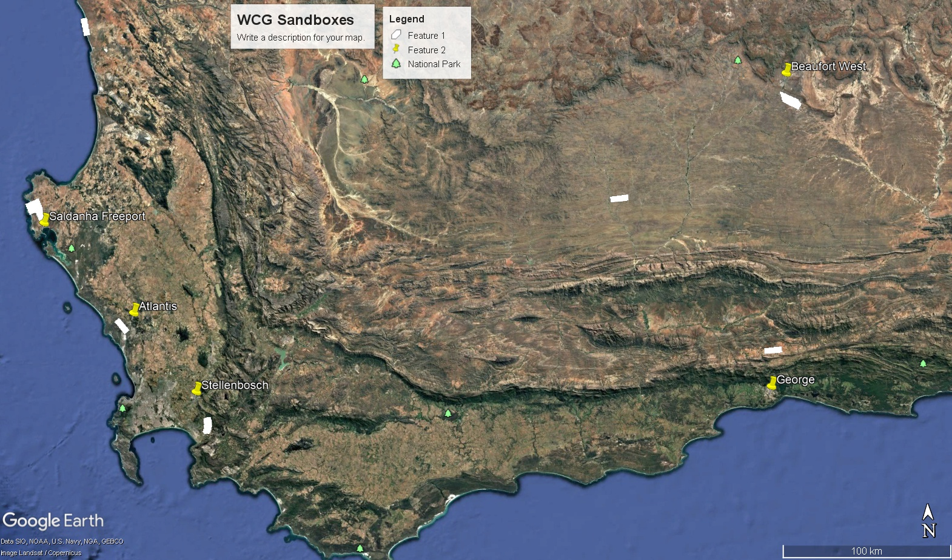
7. Timeline:
- 2024 Q1–Q3: Stakeholder engagement, technical planning, regulatory alignment
- 2024 Q4: Site selection completed
- 2025 Q1–Q2: Finalise operational/governance models
- 2025 Q3–Q4: Initiate procurement, sandbox rollout begins
- 2026 onward: Transition to PPP and scale to BVLOS/UTM operations

END
SE/C-Institute
Elivator-Pitch_Regulatory_Sandbox_Drone-UARs_July2025

