Western Cape Infrastructure Project Pipeline
Document: PROSPECTUS
Project Name: Creation of the Regulatory Sandbox for Drones and UAVs
Project Owner: Department of Economic Development and Tourism (DEDAT/WCG)
Sector: Technology / Aerospace Innovation
Date: July 2025

Acronyms & Abbreviations
AGL | Above Ground Level
ATNS | Air Traffic and Navigation Services
BVLOS | Beyond visual line of site
CSIR | Council for Scientific and Industrial Research
DAA | Detect-and-Avoid
DOI | Department of Infrastructure
DoT | Department of Transport
EVLOS | Extended visual line of site
FDI | Foreign Direct Investment
G4J | Growth for Jobs
ICAO | International Civil Aviation Organisation
IDPs | Integrated Development Plans
MVS | Minimum Viable Sandbox
PPP | Public-Private Partnership
SACAA | South African Civil Aviation Authority
STEM | Science, Technology, Engineering & Mathematics
UAS | Unmanned Aircraft Systems
UAS-SB-TF | UAS Sandbox Task Force
UAVs | Unmanned Aerial Vehicles
UTM | Unmanned Traffic Management
VLOS | Visual line of site
WCG | Western Cape Government
WCIF 2050 | Western Cape Infrastructure Framework 2050 (DOI)

- Executive Summary
The Western Cape Government (WCG) is establishing a Regulatory Sandbox for Drones and UAVs to position the Province as a global hub for drone innovation. This initiative, aligned with the Growth for Jobs (G4J) strategy and WCIF 2050 Principles, aims to provide a controlled environment for testing, regulatory adaptation, and commercialisation of unmanned aviation technologies.
Spanning 2024 to 2025, the project follows a six-phase development model that includes stakeholder engagement, technical requirements, site selection, operational design, and governance finalisation. Viable locations such as Saldanha, Atlantis, and George have been shortlisted based on airspace, infrastructure, and community impact criteria.
The sandbox supports a phased implementation model, progressing from VLOS and EVLOS to BVLOS and UTM-integrated operations, with a long-term goal of enabling fully functional drone corridors. It offers direct engagement with SACAA, ATNS, DoT, and includes frameworks for trial authorisations, exemptions, and real-time compliance monitoring.
The project is designed to de-risk investment and attract participation from drone operators, manufacturers, technology firms, and research institutions. It also supports job creation, STEM education, and inclusive economic growth through gender responsive procurement and local enterprise development.
As the sandbox transitions into a public-private partnership (PPP), investors are offered clear pathways to co-develop infrastructure, manage operations, and commercialise drone services. With regulatory alignment, scalable infrastructure, and structured governance in place, the sandbox presents a compelling investment opportunity to lead Africa’s drone innovation landscape.

- Project Description and Strategic Case
The Western Cape Government (WCG), as part of its Growth for Jobs (G4J) strategy, is initiating the creation of a Regulatory Sandbox for Drones and Unmanned Aerial Vehicles (UAVs). This project seeks to position the Western Cape as a globally recognised hub for drone innovation, enabling the region to lead in emerging aviation technologies while unlocking substantial socio-economic benefits. The sandbox will provide a controlled, real-world environment for the safe and scalable testing of drone technologies, helping to address complex regulatory barriers, facilitate commercial applications, and attract investment across the drone value chain.
Project Scope and Objectives:
The sandbox project adopts a phased development model (2024–2025), structured to ensure stakeholder alignment, regulatory compliance, and scalable implementation. The project scope includes:
A documented stakeholder approach that included a stakeholder engagement plan, an initial online survey, and a confirmed research and engagement design;
- Defining ground and airspace requirements in collaboration with regulatory authorities (ATNS, SACAA, DoT);
- Selecting a technically and commercially viable location based on weighted aviation, infrastructure, and community impact criteria;
- Developing operational, governance, and financial models to ensure a sustainable and scalable sandbox;
- Facilitating real-world testing across VLOS, EVLOS, and BVLOS operations, leading to the eventual integration of unmanned traffic management (UTM) systems;
- Supporting the growth of complementary sectors, including data analytics, advanced manufacturing, software development, and payload system design.
The overarching objective is to build a sandbox that serves as both an instrument of regulatory innovation and a catalyst for economic development, aligned with South Africa’s broader ambitions to lead in the aerospace sector.
Justification:
A Regulatory Sandbox is a policy and innovation tool that allows governments and regulators to test emerging technologies in a controlled setting. This mitigates risk while generating evidence-based insights that support smarter, more adaptive regulation. In the drone and UAV sector, current regulatory constraints (e.g., complex airspace approval, high compliance costs, limited BVLOS permissions) hinder commercial adoption and innovation. The sandbox addresses this by offering a structured pathway for testing and scaling innovations in a manner that is compliant, de-risked, and commercially viable.
This initiative supports all four WCIF 2050 Panoptic Principles:
- Equitable development through STEM education, job creation, and local innovation;
- Resilient infrastructure ecosystems built through multi-sector collaboration;
- Trust and spatial justice, ensuring that innovation benefits are widely distributed;
- Transversal planning and governance, with WCG convening stakeholders across sectors and levels of government.
Sector-Specific Analysis:
Drones and UAVs are increasingly integral to logistics, agriculture, disaster response, infrastructure inspection, and public safety. Limited regulatory flexibility however has impeded widespread commercial use in South Africa. The sandbox will function as a proof of concept for testing scalable regulatory and technological solutions, directly engaging local and international firms, researchers, and regulators.
Market Size and Demand Analysis:
The drone sector, while emerging in South Africa, holds significant growth potential. By offering a development environment for real world trials, the sandbox will unlock investment from drone operators, technology firms, manufacturers, and data services providers. Early interest is anticipated in sectors such as agritech, mining, and logistics. The sandbox also enhances the region’s attractiveness to foreign direct investment (FDI) and enables broader commercialisation pathways through international partnerships.
By anchoring the drone sector within a regulated, innovative, and collaborative ecosystem, the sandbox sets a strategic foundation for long-term growth and global competitiveness.

- Project Status and Implementation Readiness
The development of the Western Cape Regulatory Sandbox for Drones and UAVs is currently in progress, following a six-phase project framework spanning from 2024 to 2025. This phased approach ensures that the sandbox is built on a foundation of strategic planning, regulatory alignment, and stakeholder input, creating the conditions necessary for successful implementation and long-term sustainability.
Current Phase of Development:
As of early 2025, the project has completed significant milestones across the first three phases:
- Phase 1 involved detailed stakeholder mapping, development of an engagement plan, and initial outreach, including an online survey to capture needs across sectors.

- Phase 2 focused on defining the technical ground and airspace requirements, conducted through collaboration with aviation authorities such as SACAA, ATNS, and the Department of Transport. This included risk-based assessments for future Beyond Visual Line of Sight (BVLOS) operations and the groundwork for integrating Unmanned Traffic Management (UTM) systems.

- Phase 3 involved a comprehensive site selection process, using a weighted evaluation framework across ten aviation and development-related criteria. From this analysis, Saldanha, Atlantis, and George emerged as the most viable candidate sites. Each location was assessed based on security, scalability, infrastructure readiness, regulatory alignment, environmental sensitivity, and community acceptance.
The project is now entering Phase 4 and Phase 5, which involve finalising the operational model, implementation and financial frameworks, and conducting further high-level stakeholder engagements. Draft business plans and institutional arrangements are in progress, setting the stage for structured implementation.
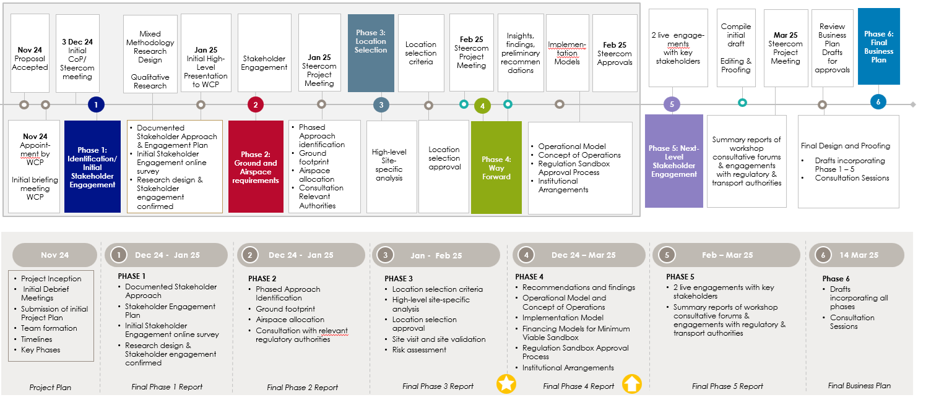
Project Timeline

Readiness for PPP or Procurement:
The proposed institutional model is designed to evolve in three phases:
- Initial public-sector leadership, with the Western Cape Government assuming full responsibility for compliance and trust-building;
- A transitional PPP model, where industry takes on increasing operational responsibility;
- A mature operating model in which the private sector leads sandbox operations, with strategic oversight retained by government.
This evolution supports investment readiness and accommodates a range of procurement or partnership opportunities. Early engagement with industry and regulatory bodies has ensured that the foundation for PPP transition is already embedded in the design.
Regulatory and Environmental Approvals:
The sandbox is being developed in alignment with existing South African Civil Aviation Regulations (Part 101) and the evolving national airspace management vision. The project team has identified key enablers for successful regulatory approvals, including:
- Formation of a UAS Sandbox Task Force (UAS-SB-TF), involving SACAA, ATNS, CSIR, and WCG;
- Development of sandbox-specific trial authorisations within a structured risk-based framework;
- Engagement with national processes to approve airspace allocation, environmental clearances, and digital regulatory tools for real-time compliance.
Additionally, the sandbox model incorporates a pathway for regulatory exemptions and alternative means of compliance to ensure flexibility without compromising safety or accountability.
Community and Stakeholder Engagement:
Stakeholder engagement is a central pillar of the sandbox model. To date, this has included:
- Online surveys and workshops with local municipalities, regulators, and industry actors;
- Validation of technical and environmental findings through site visits and consultative forums;
- Ongoing involvement of community stakeholders in the assessment of risks, local benefits, and spatial justice implications.
The next phases of the project will include two live engagement sessions with key stakeholders to finalise institutional, operational, and governance arrangements.
The combination of completed planning, stakeholder alignment, and regulatory groundwork demonstrates a high level of implementation readiness. The project is well-positioned to transition into procurement or partnership phases and begin operational rollout by 2025.

- Governance, Policy & Enabling Environment

The Western Cape Regulatory Sandbox for Drones and UAVs is grounded in a forward-thinking governance and regulatory framework that supports innovation while ensuring aviation safety, public trust, and policy alignment. It is designed to function as both a regulatory innovation tool and a platform for cross-sector collaboration, with clear institutional arrangements, enabling policies, and investment incentives.

Legal and Regulatory Framework:
The sandbox operates within the parameters of South African Civil Aviation Regulations (Part 101) and is designed to facilitate structured testing under regulated, risk-based conditions. The sandbox will make use of sandbox-specific operations specifications (OpSpecs) and a defined sandbox trial authorisation process, enabling the testing of drone technologies that may otherwise face regulatory delays or barriers.

Key enablers identified include:

- A collaborative task force (UAS-SB-TF) involving SACAA, ATNS, CSIR, and WCG to coordinate sandbox governance and regulatory input;
- Use of phased aviation operations progressing from Visual Line of Sight (VLOS) to Beyond Visual Line of Sight (BVLOS), supported by ground and hybrid Detect-and-Avoid (DAA) technologies;
- Development of digital governance tools for automated approvals, exemption tracking, and compliance reporting;
- Alignment with international standards, including ICAO's guidance on risk-based regulatory approaches and unmanned aircraft integration.

The sandbox also enables exemptions and alternative means of compliance, governed under Part 11 of the Civil Aviation Regulations. These legal mechanisms are essential to accelerate testing and commercialisation while still operating under clearly defined safety protocols.

Government Policies:
The project is directly aligned with the Western Cape’s Growth for Jobs (G4J) strategy and reflects the WCIF 2050 Panoptic Principles by:

- Promoting equitable and inclusive economic growth through infrastructure innovation;
- Supporting resilient, sustainable systems via ecosystem collaboration;
- Prioritising stakeholder trust and spatial justice in site selection and community engagement;
- Enabling transversal governance through multi-sector coordination.

In this mission-oriented approach, the Western Cape Government does not only act as a regulator but as a convenor of innovation ecosystems, engaging public and private actors to solve complex challenges that single entities cannot address alone.

Governance Role:
A robust institutional governance structure is being established, including:

- A multi-stakeholder Steering Committee for strategic oversight;
- A Technical Advisory Board to ensure alignment with evolving technology and international best practice;
- A Regulatory Advisory Board to liaise with SACAA, ATNS, and the Department of Transport;
- An Operational Management Team responsible for daily oversight, compliance monitoring, and performance tracking;
- An Industry and Community Engagement Forum to ensure transparency, feedback, and responsiveness.

This governance structure supports accountability, agility, and coordination across all phases of implementation and aligns with international sandbox models that transition from public sector leadership to private sector operational control.
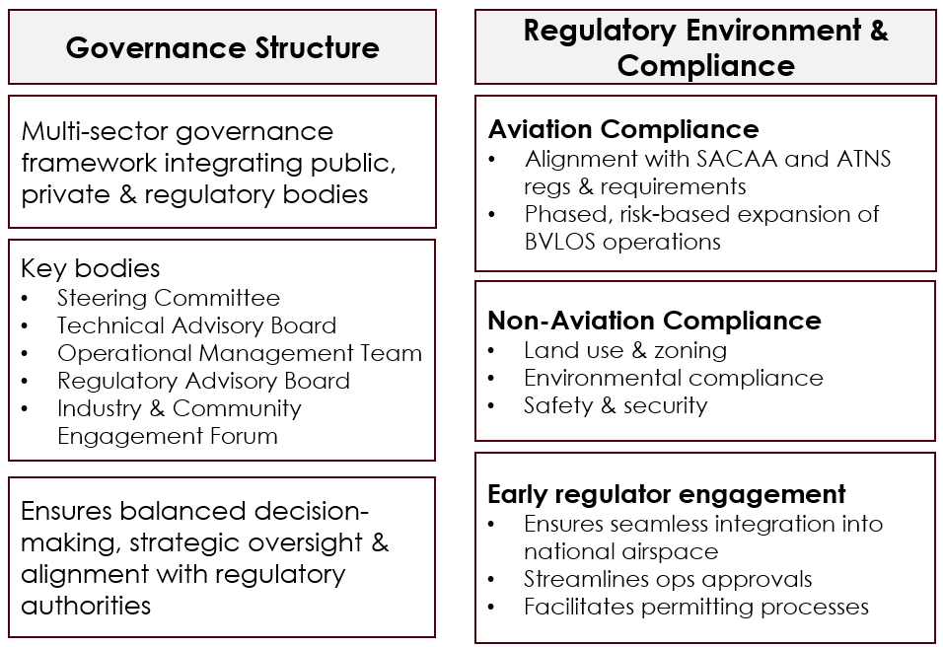
Governance Structure & Regulatory Environment

Investment Needs and Policy Incentives:
The sandbox is designed with scalability and investment in mind. Investment needs are structured around three primary areas:

- Infrastructure development for test environments and digital systems
- Operational capacity to manage trials, data, and compliance
- Commercial pathways that incentivise private sector participation and FDI

To attract investment, the sandbox will offer:

- Streamlined trial approvals;
- Access to exclusive test environments;
- Opportunities to shape future regulations;
- Early market access and potential for public-private partnerships as the sandbox transitions from public to private leadership.

The enabling environment created through this governance and policy framework is fundamental to ensuring that the sandbox becomes a sustainable, scalable, and investor-friendly innovation ecosystem.

- Economic and Commercial Viability
The Western Cape Regulatory Sandbox for Drones and UAVs has been conceptualised as a high-impact infrastructure and innovation platform designed to offer both economic and commercial returns. Its implementation is structured to deliver value-for-money, support scalable commercial applications, and unlock broader macroeconomic benefits through the development of the regional drone industry and its associated value chains.
Value-for-Money Assessment:
The project adheres to the value-for-money principles outlined in the WCIF 2050. By enabling regulated real-world testing of drones in a controlled, cost-effective manner, the sandbox will reduce duplication of efforts, lower regulatory friction, and accelerate time-to-market for drone innovations. It also creates the foundational infrastructure needed to support a high-potential, emerging sector with applications in logistics, agriculture, inspection, disaster response, and more.
Cost-Benefit Analysis:
Initial financial modelling has been undertaken using a multi-layered approach focused on ensuring the viability of the minimum viable sandbox (MVS) for the Western Cape Government as project sponsor. This includes modelling of infrastructure requirements, operational costs, and support mechanisms for sandbox users (e.g., researchers, start ups, private firms). International best practice and lessons from other drone sandboxes and corridors have informed this framework, while incorporating local conditions such as regulatory complexity and socio-economic development needs.
Risk Evaluation:
The sandbox adopts a phased, risk-based operational model, starting with Visual Line of Sight (VLOS) and evolving toward full Beyond Visual Line of Sight (BVLOS) and Unmanned Traffic Management (UTM) integration. This approach reduces technical and safety risks while enabling iterative learning and regulatory adaptation. Environmental, zoning, and community risks are addressed through stakeholder engagement and site-specific assessments.
Additionally, regulatory risk is mitigated through structured trial authorisations, early engagement with SACAA and ATNS, and proposed digital compliance tools that allow for real-time monitoring and oversight.
Economic Multipliers and Macroeconomic Benefits:
The sandbox initiative is expected to generate high economic multipliers through:
- Job creation in drone services, data analytics, manufacturing, and support services;
- Skills development and STEM education aligned with technology sectors;
- Increased research and development activity;
- Attraction of both local and foreign direct investment (FDI).
Over time, the sandbox will serve as a catalyst for regional competitiveness, enabling the Western Cape to lead in the drone sector across Africa and supporting national ambitions for aerospace leadership.
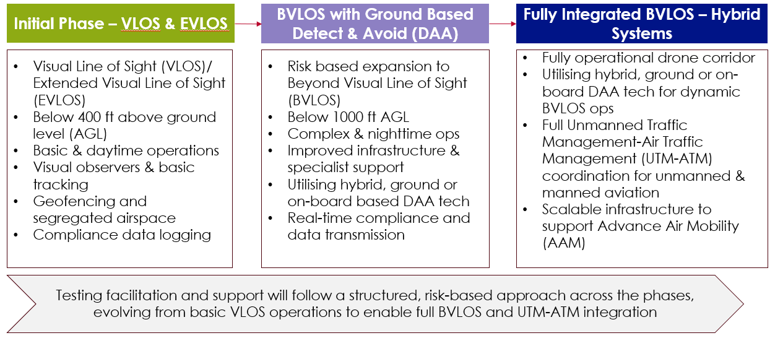

Structured Risk-Based Approach

- Financial Requirements and Funding Strategies
The Western Cape Regulatory Sandbox for Drones and UAVs is designed as a phased infrastructure and innovation platform that requires a multi-layered financing approach to ensure both operational viability and long-term scalability. The financial planning process focuses on establishing a minimum viable sandbox (MVS), with a clear trajectory for progressive growth, public-private partnership (PPP), and commercial integration.
Total Project Cost Breakdown:
While specific cost figures are still in development, the financial model distinguishes between several key components:
- Infrastructure costs for setting up secure ground operations, site facilities, communication systems, and initial airspace management capabilities;
- Operational and staffing costs for the management team, compliance monitoring, and stakeholder engagement;
- Technology and digital tools, including systems for automated trial approvals, exemption tracking, data logging, and UTM integration;
- Engagement and governance structures, such as advisory boards and forums;
- Scaling costs, associated with the expansion of sandbox operations from Visual Line of Sight (VLOS) to Beyond Visual Line of Sight (BVLOS) and full Unmanned Traffic Management (UTM) integration.
This structured approach allows the sandbox to evolve in phases while aligning cost with growth and value delivery.
[No cost breakdown is provided. Even a range or high-level estimate would improve investor clarity]
Funding Sources:
The initial development is publicly funded, led by the Western Cape Government (WCG), which assumes responsibility for infrastructure, regulatory alignment, and governance in the early phase. The funding model is informed by global sandbox precedents but contextualised for local constraints and opportunities. It also reflects the unique role of the WCG as both a facilitator and project sponsor during the foundational stages.
Revenue Models:
As the sandbox matures, it will introduce revenue-generating mechanisms such as:
- User fees for private firms conducting trials and demonstrations;
- Subscription or membership models for ongoing access to sandbox facilities;
- Tiered pricing models based on trial complexity or regulatory support required;
- Partnership agreements with R&D institutions, service providers, and drone manufacturers.
These mechanisms ensure that the sandbox is not only cost-recoverable but also commercially sustainable over time.
Innovative Financing Mechanisms
The sandbox design accommodates blended financing approaches, including:
- Public-private partnerships (PPPs) as the project transitions into more commercially-led phases;
- Non-monetary contributions from industry participants (e.g. equipment, expertise, or data);
- Strategic investment partnerships with firms seeking early access to airspace testing and regulatory alignment;
- International funding and technical cooperation, particularly in areas of safety, compliance, and UTM development
This flexible financing strategy reflects both the complexity and opportunity of building a globally competitive drone innovation ecosystem in the Western Cape.

- Project Feasibility, Approvals and Infrastructure Planning
The Western Cape Regulatory Sandbox for Drones and UAVs has undergone a rigorous feasibility and planning process designed to ensure that the initiative is technically sound, environmentally compliant, and operationally scalable. The project is being implemented through a structured, six-phase framework that incorporates feasibility assessment, stakeholder engagement, and regulatory alignment to enable informed site selection and infrastructure development.
Feasibility Study Findings:
Comprehensive feasibility analysis has been central to the early phases of the project. A detailed site selection study was conducted across six potential locations: Saldanha, Atlantis, George, Stellenbosch, Karoo (Beaufort West), and Karoo (Prince Albert). Using a weighted scoring system based on ten key criteria, including aviation security and safety, airspace availability, infrastructure readiness, regulatory compliance, environmental and community impact, and investor appeal, three sites were identified as most viable: Saldanha, Atlantis, and George.
The criteria were developed with input from aviation authorities and industry stakeholders and were aligned to the operational requirements of drone testing, particularly with respect to airspace segregation, access to support infrastructure, and scalability for BVLOS operations. Each shortlisted site underwent site validation visits, risk assessments, and cross-checks with regulatory bodies to ensure readiness for implementation.
Master Plan Integration
The sandbox is being developed in alignment with broader provincial and national infrastructure objectives, particularly the Growth for Jobs (G4J) strategy and the WCIF 2050 Panoptic Principles. This ensures that the initiative supports not only aviation innovation but also wider spatial justice, economic inclusion, and resilient infrastructure ecosystems.
The phased operational model, from VLOS to fully integrated BVLOS and drone corridor operations, aligns the sandbox with evolving regulatory requirements and aviation best practices. It also allows integration with Unmanned Traffic Management (UTM) infrastructure as a long-term strategic goal.
Alternative Evaluation
Each potential site was assessed against both aviation-specific and developmental criteria, including ground and air risk factors, regulatory and zoning compliance, access to infrastructure, environmental sensitivity, and proximity to research and talent ecosystems. The scoring methodology enabled a transparent, evidence-based comparison across locations. Sites with significant environmental or regulatory barriers, such as Stellenbosch, were deprioritised due to concerns around biodiversity risk, community disruption, and airspace congestion.
Infrastructure Planning and Prioritisation
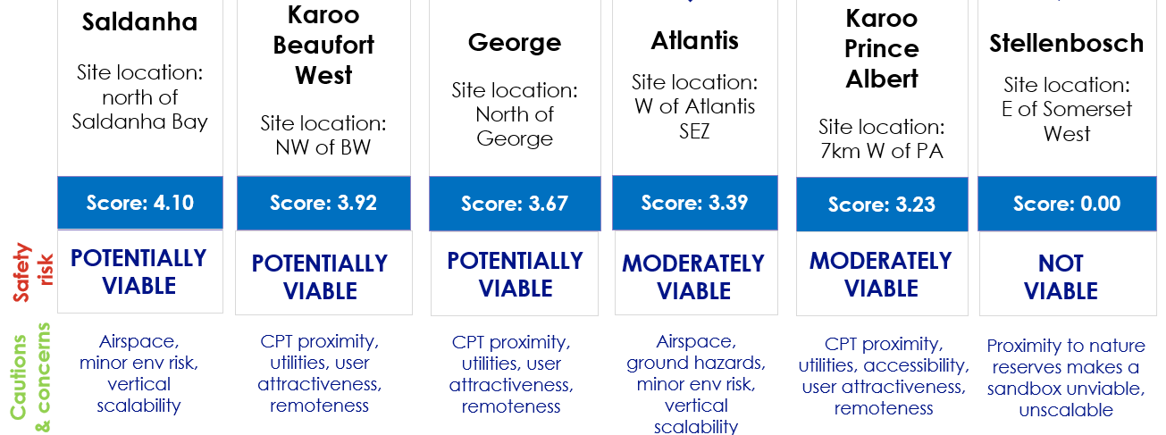
Infrastructure planning for the sandbox includes basic operational facilities for VLOS testing in the initial phase, followed by upgrades to support BVLOS trials and UTM integration. Priority has been placed on access to secure airspace, physical infrastructure (e.g., electricity, water, sanitation), and digital tools for trial tracking and compliance reporting. The infrastructure plan is intentionally scalable to support the sandbox’s transition from public leadership to private-sector operation and commercialisation
Site Scoring Table

- Delivery Mechanism and Procurement Strategy
The Western Cape Regulatory Sandbox for Drones and UAVs is structured around a phased implementation model designed to ensure effective delivery, manageable risk, and gradual transfer of operational responsibility from the public to the private sector. The delivery mechanism and procurement strategy have been carefully aligned with global best practices while remaining sensitive to the local context, regulatory environment, and infrastructure readiness.
Phased Implementation:
The sandbox’s implementation will occur across three defined phases:
- Initial Phase – Public Leadership and Establishment
In this phase, the Western Cape Government (WCG) leads the development, governance, and daily operations of a minimum viable sandbox (MVS) focused on Visual Line of Sight (VLOS) and Extended VLOS (EVLOS) operations below 400 feet above ground level (AGL). This phase includes the establishment of basic infrastructure, operational governance, and foundational regulatory alignment.
- Transition Phase – PPP and Expansion
As the sandbox gains operational maturity, it will transition into a public-private partnership (PPP) model. In this phase, private sector partners will gradually assume operational responsibilities, while WCG retains oversight and strategic control. This phase will enable the introduction of more complex operations, including Beyond Visual Line of Sight (BVLOS) testing, and expansion of the physical and airspace footprint.
- Full Maturity Phase – Private Sector Leadership with Public Oversight
At full maturity, the sandbox will be industry-led, with the private sector managing operations under a governance framework that includes public oversight. This phase includes integration of Unmanned Traffic Management (UTM) systems and support for commercial drone corridors.

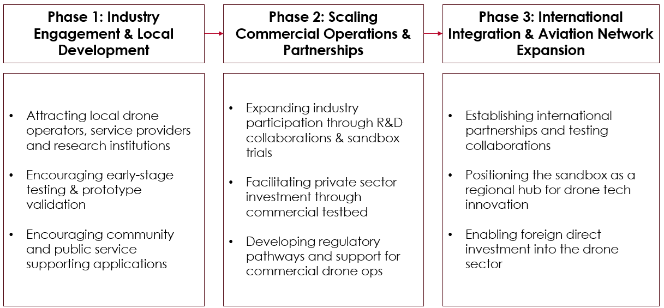
Phased Operational Model

Procurement Methods and Bidding Process
Procurement for the initial phase will be led by WCG and may involve open or targeted tenders for the development of infrastructure, provision of digital systems, and management of operational components. Procurement processes will be transparent and consistent with public sector procurement standards, ensuring fair competition and the inclusion of innovative suppliers.
During the transition and maturity phases, the procurement model may evolve to include joint ventures, co-investment agreements, or service contracts with private partners. Competitive bidding processes will be used to select qualified industry participants based on technical capacity, compliance history, and alignment with sandbox goals.
Supplier Selection and Risk-Sharing Mechanisms
Suppliers and partners will be selected based on their ability to contribute to the sandbox’s innovation, safety, and commercialisation objectives. A strong emphasis will be placed on compliance with regulatory standards, operational scalability, and stakeholder engagement.
The phased model allows for balanced risk-sharing. In the early stages, risk is borne primarily by the public sector, while later phases introduce shared or fully private risk, especially for commercial services, infrastructure scaling, and advanced operational capabilities.
[The document outlines the phased transition to private sector leadership but lacks detail on governance handover triggers, success thresholds, etc.]

- Project Communication and Stakeholder Engagement
The success of the Western Cape Regulatory Sandbox for Drones and UAVs is underpinned by a strong and inclusive stakeholder engagement strategy. From inception, the project has prioritised transparent communication, multi-sectoral collaboration, and alignment with public, private, and regulatory interests. This approach ensures that the sandbox responds to both technical requirements and broader socio-economic expectations.
Investor Engagement Strategies:
The sandbox initiative is designed to be investment ready, with communication strategies aimed at attracting local and international private sector interest. These strategies include:
- Clear articulation of commercial value: Highlighting regulatory flexibility, early access to airspace, and opportunities for R&D and commercial testing;
- Structured engagement platforms: Industry participants are integrated through forums and advisory boards, offering a voice in governance and operational design;
- Phased partnership pathways: Investors are introduced to a roadmap that transitions from public-led operations to joint ventures and private-sector leadership, with defined roles and risk-sharing models;
- Data-driven trust-building: Through sandbox trials and feedback loops, investors are provided with performance insights, regulatory certainty, and proof of market readiness.
These strategies collectively position the sandbox as a credible, de-risked platform for commercial experimentation and investment.
Community Participation
Community engagement is embedded in both the site selection and implementation planning phases. Each potential location was evaluated not only on technical and regulatory suitability but also on:
- Community acceptance;
- Impact on local services and land use;
- Potential for job creation and economic inclusion
Two live stakeholder engagements are scheduled during the current phase to gather feedback on the operational model and institutional arrangements. Local governments have also been engaged to assess spatial impacts, land zoning, and environmental sensitivities. This community-first approach is aligned with the WCIF 2050 principle of spatial justice and aims to ensure that the benefits of the sandbox are widely and equitably distributed.
Government and Regulatory Interactions
The project has cultivated close relationships with key national regulatory bodies, including the South African Civil Aviation Authority (SACAA), Air Traffic and Navigation Services (ATNS), and the Department of Transport. These engagements have facilitated:
- Definition of airspace requirements;
- Development of sandbox-specific operational authorisations;
- Planning for phased integration of Beyond Visual Line of Sight (BVLOS) operation;
- Creation of a UAS Sandbox Task Force (UAS-SB-TF) to formalise regulatory collaboration
By fostering sustained dialogue with regulators and government departments, the sandbox ensures policy alignment, facilitates faster approvals, and builds the institutional trust needed for long-term success.

- Special (e.g. gender) Procurement Actions and Social Impact
The Western Cape Regulatory Sandbox for Drones and UAVs has been designed not only as a technological and regulatory innovation platform, but also as a catalyst for inclusive development, aligned with the WCIF 2050 Panoptic Principles and the Growth for Jobs (G4J) strategy. These frameworks position infrastructure and innovation as key levers for spatial justice, human development, and equitable opportunity. As such, the sandbox includes deliberate focus areas for gender responsive procurement, social benefit generation, and environmental sustainability.
Gender-Responsive Procurement
While specific gender procurement targets are not explicitly outlined in the current project documentation, the sandbox aligns with the WCIF 2050 commitment to building sustainable stakeholder value and promoting inclusive value chains. The sandbox’s implementation and procurement strategy, particularly as it moves into phases involving public-private partnerships (PPPs) and service provision, creates opportunities to:
- Encourage participation by women-owned enterprises in drone operations, data services, consulting, and compliance support;
- Integrate gender sensitive criteria into supplier selection and local subcontracting frameworks;
- Prioritise training and skills development programmes that are accessible to women and youth in STEM fields
As the sandbox matures, gender responsive procurement can be further embedded through supplier guidelines, partnership agreements, and governance oversight.
Social Benefits
A central aim of the sandbox is to generate socio-economic returns alongside technological advancement. Key social impacts include:
- Job creation in drone operations, software development, advanced manufacturing, and supporting industries;
- STEM education promotion, with an emphasis on building local talent and addressing historical skills gaps;
- Development of regional innovation ecosystems that integrate SMMEs, research institutions, and community-based actors;
- Economic growth in underdeveloped or peripheral regions, with sites such as Saldanha and Atlantis offering strong potential for community upliftment.
These social objectives are integrated into the project’s design through location selection criteria, community engagement plans, and institutional governance mechanisms.
Sustainability and Environmental Compliance
Environmental responsibility has been embedded into the project through both site assessment and regulatory planning. All candidate locations were evaluated for:
- Environmental impact (including proximity to sensitive biodiversity zones);
- Land use compatibility with municipal zoning and integrated development plans (IDPs);
- Potential for long-term ecological risks associated with drone testing and infrastructure development.
Only sites with manageable environmental risks, such as Saldanha, George, and Atlantis, were shortlisted. Moreover, collaboration with regulatory bodies ensures that environmental compliance is embedded into the sandbox’s operational protocols, including flight authorisation and risk assessment processes

- Operations and Maintenance Strategy
The Western Cape Regulatory Sandbox for Drones and UAVs is designed with a long-term operational and asset management strategy that ensures performance, compliance, resilience, and scalability. The strategy supports the sandbox’s phased evolution, from basic operations to advanced drone corridor integration, while maintaining cost effectiveness and regulatory integrity throughout.
Long-Term Asset Management
The sandbox will be developed with a minimum viable infrastructure footprint during its initial phase, focusing on Visual Line of Sight (VLOS) and Extended VLOS operations. This includes basic operational facilities, secure airspace infrastructure, and data collection systems. As the sandbox scales to support Beyond Visual Line of Sight (BVLOS) operations and Unmanned Traffic Management (UTM), asset planning will include:
- Scalable infrastructure designs for modular expansion;
- Strategic co-investment models during the PPP transition phase;
- Clear public-private ownership roles over time, with the Western Cape Government (WCG) initially retaining full control of strategic assets.
This enables a structured handover of operational responsibilities to private sector partners while ensuring long-term asset utility and sustainability.
Performance Monitoring
The sandbox is built on a data-driven governance model. An Operational Management Team will be established to oversee:
- Scheduling and logistics;
- Compliance and safety monitoring;
- Performance tracking and data reporting.
Regular audits, key performance indicator (KPI) reviews, and integration of user and stakeholder feedback will ensure the sandbox remains responsive to technological and regulatory developments. Oversight bodies such as the Regulatory Advisory Board and Technical Advisory Board will provide further layers of quality assurance and adaptive management.
Digital Technology Leverage
Digital technology is core to the sandbox’s operations. Tools will be deployed to enable:
- Real-time compliance monitoring;
- Automated trial authorisation processes;
- Data logging and performance analytics;
- Dynamic UTM integration to manage drone traffic in shared airspace
These tools support operational safety, regulatory transparency, and efficient user experiences. They also provide a digital backbone for integrating emerging standards in unmanned aviation governance.
Resilience Planning and Climate Adaptation
Resilience is embedded in both site selection and infrastructure planning. Candidate sites were assessed for environmental impact and ground and airspace risk. Infrastructure is planned to be adaptable to changes in land use, airspace availability, and climate related disruptions. As the sandbox scales, further measures will include:
- Infrastructure flexibility to accommodate climate variability;
- Consideration of coastal and rural site vulnerabilities;
- Engagement with municipalities to align on long-term environmental planning
The overall strategy ensures that the sandbox operates efficiently, adapts effectively, and evolves sustainably.
[While ‘performance monitoring’ is discussed, a formalised M&E strategy (e.g. KPIs, reporting cycles) is not explicitly outlined]

- Conclusion and Call to Action
The Western Cape Regulatory Sandbox for Drones and UAVs represents a transformative opportunity to unlock innovation, investment, and inclusive growth in South Africa’s emerging aviation sector. Anchored in a strong policy framework and backed by structured regulatory support, this initiative offers investors and private sector partners access to a globally competitive testing environment, strategically located in one of Africa’s most technologically advanced regions.
Summary of Investment Benefits:
- First mover advantage in shaping the future of unmanned aviation in South Africa;
- De-risked testing environment supported by regulatory bodies including SACAA, ATNS, and the Department of Transport;
- Access to exclusive test corridors and segregated airspace, enabling VLOS, BVLOS, and UTM integrated operations;
- Opportunity to participate in a phased public-private partnership model, with defined roles in infrastructure, operations, and commercialisation;
- Direct involvement in the development of regulatory pathways, performance metrics, and digital governance tools;
- Engagement in a project aligned with South Africa’s ambitions for aerospace leadership, regional economic inclusion, and global market positioning.
In addition to strong commercial incentives, the sandbox supports STEM development, job creation, skills training, and the growth of supporting industries such as data analytics, payload systems, and advanced manufacturing.
Next Steps
The project is currently entering Phase 4 and Phase 5, with the finalisation of operational, financial, and governance models. Live stakeholder engagements and consultations with regulatory authorities are underway to complete the business plan and implementation roadmap.
Prospective partners and investors are encouraged to:
- Engage with the project team to explore investment models, pilot opportunities, and partnership frameworks;
- Participate in upcoming stakeholder sessions to help shape the operational design and identify use cases;
- Submit formal expressions of interest aligned with the sandbox’s phased rollout strategy.
Opportunities are available across infrastructure provision, operational management, compliance services, and technology integration.
Contact Details and Proposal Submission
To express interest or request further information, stakeholders may contact:

Western Cape Government – Drone Sandbox Project Team
Project Coordination Unit
xxxxx

Other Areas of Project Improvement:
Shared Reward Mechanisms (Mission Orientated Approach – Chapter 3, WCIF 2050)
While the project is strong on risk-sharing, it’s less explicit on how the public sector retains a share of the upside.
- No mechanism for public ROI: The Project lacks detail on equity stakes, licensing agreements, or data monetisation models, etc that would return value to the public.

- Public infrastructure, private monetisation: While test sites and airspace are developed publicly, revenue models (user fees, tiered pricing) are geared toward cost recovery, not public benefit (reinvesting part of private operator fees into community-based drone training programs, STEM education initiatives, or local SMME development, etc).

- IP and data ownership unclear: No indication if data generated through trials will be publicly owned, licensed, or open-access.

END
SE/C-Institute
Prospectus_Regulatory_Sandbox_Drone-UARs_July2025

