Western Cape Infrastructure Project Pipeline
Document: Elevator Pitch
Project Name: Provincial Archives Project
Project Owner: Department of Cultural Affairs and Sport (DCAS) / Western Cape Government
Sector: Economic
Date: July 2025

1. Project Summary:
The Provincial Archives Project is a six-phase, construction-ready infrastructure investment to expand the Western Cape Archives and Records Service (WCARS). With over 57,000 linear meters of backlog, WCARS has reached full capacity, risking legal non-compliance and fragmented governance. Phase 1, valued at R328.7 million, includes a purpose-built archival facility featuring high-density shelving, cold storage, and digital infrastructure. The project strengthens transparency, improves service delivery, and ensures the long-term preservation of public records across the provincial government.

2. Project Status:
Phase 1 is fully scoped, designed, and construction ready. Planning, costing, and technical documentation are complete, and the project has been submitted for evaluation through the Panoptic Evaluation Scoring Sessions. The site is ready for demolition and new construction, subject to final budget approval. The project aligns with the WCIF 2050, WCIS 2050, and WCIIP frameworks, affirming its readiness and strategic fit.

3. Financial Needs:
Phase 1 requires R328.7 million, covering 8,313 m² of construction. The full six-phase programme totals approximately R1.22 billion. All estimates include escalation, professional fees, and contingency allowances. The project is currently publicly funded but presents opportunities for future innovative financing. Cost-benefit assessments confirm long-term savings, operational efficiencies, and a reduction in non-compliant or outsourced record storage.

4. Private Sector Opportunity:
Private sector investors can engage through:
- Professional services tenders for design, engineering, and archival systems installation;
- Construction and supply contracts under open competitive procurement processes;
- Future opportunities in digital infrastructure, scanning, and long-term archiving technology;
- Scenario-based funding/investment strategies when alternative funding models is required.

5. Key Parties:
- Department of Cultural Affairs and Sport (DCAS) [Project Owner]
- Western Cape Archives and Reports Services (WCARS)
- Department of Infrastructure (DOI) [Implementing Partner/Planning Authority]
- Provincial Treasury, WC [Budget Oversight/Strategic Alignment]
- WCG EXCO & Cabinet-level structures [overarching governance and political oversight]
- All Client Departments:
  - All WCG Departments
  - Western Cape Municipalities
  - Western Cape Public Entities
  - Office of the Premier
  - Western Cape Provincial Parliament

6. Map of the Project:
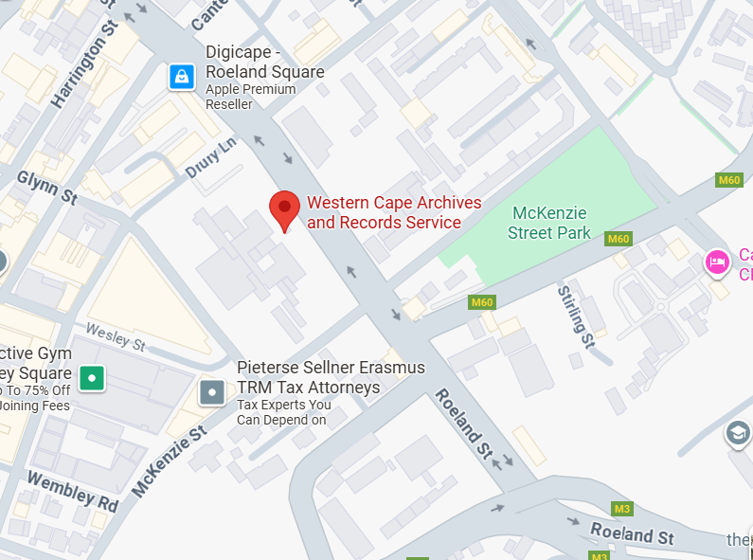

72 Roeland St, Gardens, Cape Town, 8001

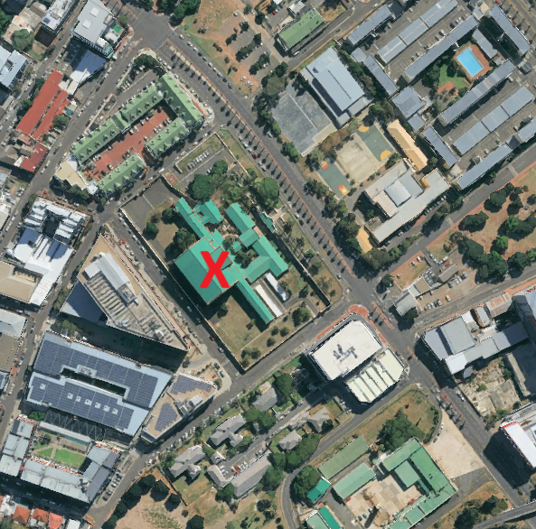

7. Timeline:
- Planning Completion: 2024
- Phase 1 Construction Ready: 2025
- Tender and Procurement: 2025–2026
- Phase 1 Construction Period: 2026–2028
- Phases 2–6: Staggered implementation through 2035 (subject to funding and prioritisation)

END
SE/C-Institute
Elivator-Pitch_Archives-Project_July2025

