Western Cape Infrastructure Project Pipeline
Document: PROSPECTUS
Project Name: Provincial Archives Project
Project Owner: Department of Culture, Arts and Sport (DCAS/WCG)
Sector: Economic
Date: August 2025

- Executive Summary
The Provincial Archives Project is a construction-ready, legally mandated infrastructure investment designed to address an urgent storage capacity shortfall at the Western Cape Archives and Records Service (WCARS). With an estimated 57,000 linear meters of unaccommodated records, the current capacity situation compromises legal compliance, undermines governance, and limits public access to essential documentation.
The full project is structured across six phases, with a total estimated value of R1.22 billion. The Phase 1 of the project which is fully scoped, costs R328.7 million and is ready for implementation. This phase includes the demolition of outdated infrastructure and the construction of a five-storey archival facility which has advanced mobile shelving, cold storage, scanning services, and digital transformation infrastructure.
Aligned with the Western Cape Infrastructure Framework (WCIF) 2050, Western Cape Infrastructure Strategy (WCIS) 2050, and the Panoptic Evaluation Framework, the project contributes to spatial justice, transversal governance, and long-term sustainability. It also strengthens public trust by enhancing access to records required for estate resolution, legal matters, and public history.
The Provincial Archives Project now seeks investment and approval for execution, positioning itself as a cornerstone of institutional memory, transparency, and citizen rights in the Western Cape.

- The Project Description and Strategic Case
In order to address a critical storage capacity shortfall that is directly preventing legal compliance, public service delivery, and democratic accountability, the Provincial Archives Project suggests a strategic, six-phase infrastructure expansion of the Western Cape Archives and Records Service (WCARS). The project complies with Schedule 5(a) of the Constitution, which gives Provincial governments full authority over archives other than National archives. The Western Cape Act (Act No. 3 of 2005), which mandates that the province maintain a Provincial Archives and Records Service, offers additional legislative guidance.
WCARS serves as the central archival repository for all Western Cape Government (WCG) departments, municipalities, public entities, the Office of the Premier, and the Provincial Parliament. It has now however reached full storage capacity, with an immediate backlog of over 57’000 linear meters. This shortfall has prompted ad hoc measures with consequences that are unsustainable and non-compliant. These include instances where records are either held beyond their authorised retention periods within government departments or, are outsourced to costly commercial storage solutions. These measures pose a serious risk to record integrity, legal defensibility, and governance continuity.
The Project Scope includes Phase 1 of the project which is fully designed, construction ready, and carries an estimated cost of R328.7 million. It will involve the demolition of old infrastructure and the phased construction of new archival facilities. A five-story stack building with two basements is being constructed during this phase. It will have cold storage, scanning capabilities, digital records infrastructure, and contemporary mobile shelving. Subsequent phases cover the refurbishment of existing stacks, further expansion for future demand, new administration areas, and a conference facility. The full six phase masterplan reflects a long-term vision for an archival institution.
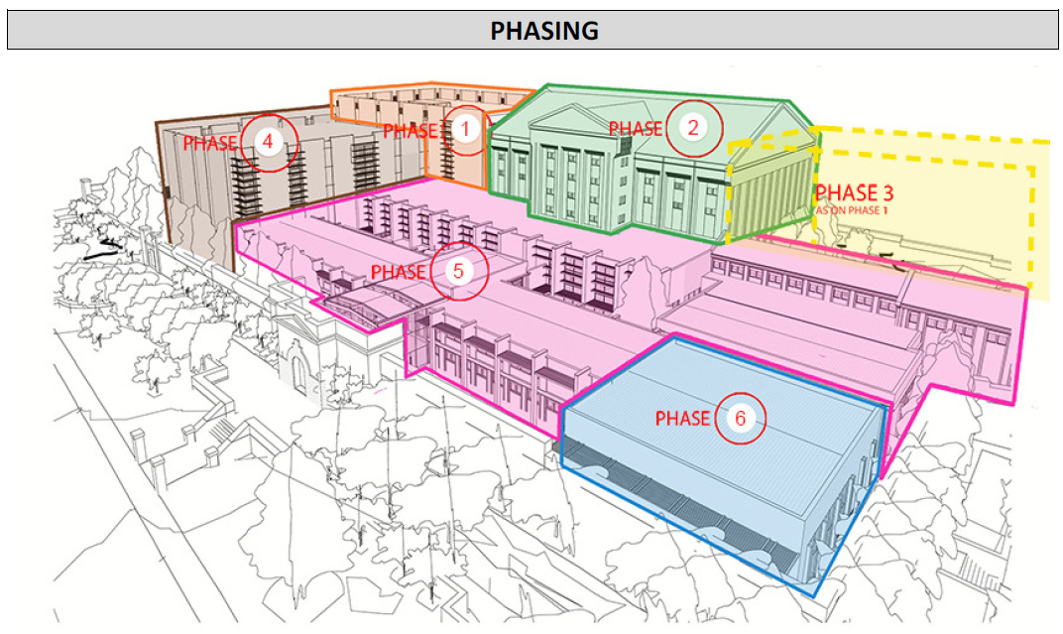
Figure 1: Phased Development Overview-Phases 1 to 6

Sector-specific analysis - analysis of the archives and records management sector demonstrates that WCARS is a vital component of social justice, governance, and cultural continuity rather than just a records warehouse. Ineffective record keeping is a common obstacle to efficient oversight according to Auditor-General reports. By guaranteeing archival integrity, promoting government accountability, and facilitating access to historical records, WCARS reduces these risks. Additionally, the institution plays a critical role in advancing digital transformation and inclusive access to information. This aligns with the Western Cape Infrastructure Strategy 2050 (WCIS 2050) and the Westen Cape Infrastructure Framework (WCIF 2050) Panoptic Principles.

- Project Status and Implementation Readiness
The Provincial Archives Project is currently at an advanced stage of planning with Phase 1 fully construction ready. The architectural designs, costing estimates, and phasing strategy have been completed, enabling immediate progression to implementation pending budget allocation and final approvals. As outlined in the Roeland Archives Project – Workstage 03 report and the Masterplan Phasing document, the project has been developed through a planning process led by the Department of Infrastructure (DOI) in partnership with the Department of Cultural Affairs and Sport (DCAS). The Phase 1 development, which includes demolition of the outdated South East Wing and construction of a five-storey archival stack facility with two basement levels, is technically prepared for tendering and execution.
The detailed cost estimate for Phase 1, confirms a total projected expenditure of R328,719,289 (including VAT and professional fees). This cost reflects escalations calculated over the pre-construction and construction periods and includes allowances for contingencies, design development, and professional disbursements.
The project’s readiness for evaluation within structured public infrastructure frameworks is further confirmed by its inclusion in the Request for Projects document issued for the Panoptic Evaluation Scoring Sessions which were scheduled for July 2025. This signals its alignment with the Western Cape Infrastructure Framework (WCIF 2050), the Western Cape Infrastructure Strategy (WCIS 2050), and the Infrastructure Implementation Plan (WCIIP 2050), all of which require evidence-based, policy-aligned, and investment ready proposals. In preparation for this process, the Department has already assembled key documentation including project plans, costing schedules, and strategic alignment statements.
While specific regulatory and environmental approvals are not detailed in the current documentation, the planning and costing process led by the DOI suggests that technical compliance and planning permissions are being managed as part of standard project preparation protocols. Additionally, the project aligns with legislative mandates under the Provincial Archives and Records Service of the Western Cape Act, 2005, indicating a strong legal foundation.
Although explicit documentation of community or stakeholder consultation is not included, the project is being submitted for transversal evaluation under the WCIF 2050 Panoptic Principles, an approach that requires collaborative, cross-sectoral planning and governance. Its strategic alignment with service delivery, governance, and heritage mandates makes it highly relevant to a broad base of public stakeholders and beneficiaries.

- Governance, Policy & Enabling Environment
The Provincial Archives Project is firmly grounded in a well-defined legal and policy framework that mandates the establishment, maintenance, and expansion of the Western Cape Archives and Records Service (WCARS). Its legal basis stems from Schedule 5(a) of the Constitution of South Africa, which designates “Archives other than the National Archives” as an exclusive provincial legislative competence. In line with this constitutional responsibility, the Provincial Archives and Records Service of the Western Cape Act, 2005 (Act No. 3 of 2005) obliges the Western Cape Government to establish and manage a provincial archives and records service.
Governance oversight is led by the DCAS, which is the mandated department responsible for archival services in the province. The project is being implemented in partnership with the DOI, which provides technical, engineering, and project management expertise. This collaboration demonstrates compliance with Principle 4 of the Panoptic Evaluation Framework, emphasizing transversal governance and integrated delivery.
Policy alignment is reinforced through the project’s connection to the WCIF 2050 and its implementation through the WCIS 2050 and WCIIP 2050. These strategic policy instruments emphasise infrastructure led development, long-term sustainability, and equitable public service. The Panoptic Principles further guide the project’s evaluation, particularly in relation to innovation, resilience, spatial justice, and long-term stakeholder value.
The enabling environment for this project includes participation in the Panoptic Evaluation Scoring Sessions, a province wide infrastructure prioritisation process aimed at building a credible, investor ready pipeline. Through this mechanism, the project is being assessed on its policy compliance, statutory readiness, and delivery potential. It also creates space for aligning the project with broader investment frameworks and ensures that it meets the expectations of both public sector funders and external partners.
Although the documents do not list explicit financial policy incentives, the escalation adjusted cost estimates and inclusion of professional fees and contingency provisions indicate a comprehensive understanding of the project’s investment needs. Phase 1 alone requires R328 million, with the entire six-phase programme valued at approximately R1.22 billion, as detailed in the infrastructure motivation submitted to the DOI. This positions the project as a major capital investment opportunity that supports good governance, legislative compliance, and long-term public value.

- Economic and Commercial Viability
The Provincial Archives Project represents a strategically sound and economically viable public infrastructure investment. It also has clear value-for-money considerations, macroeconomic benefits, and risk mitigation aligned with the Panoptic Infrastructure Principles of the WCIF 2050.
A robust value-for-money assessment is embedded in the project’s design and procurement readiness. The estimated cost of Phase 1 stands at R328,719,289 (incl. VAT and professional fees) for 8,313 m² of constructed area, according to the February 2024 cost estimate (see: Figure 2: Cost Summary Table below). The design leverages efficient mobile shelving, digital infrastructure, cold storage, and scanning facilities, all aimed at optimising space and long-term operational value. A value engineered alternative (Option 2) was also costed at R280 million for a reduced 6,975 m² footprint, demonstrating fiscal prudence and scenario planning by the DOI. These figures incorporate detailed escalation provisions (47% pre-construction, 7% during construction), a 22% allocation for professional fees, and a 5% total contingency, ensuring planning accuracy.
The project provides a strong cost-benefit rationale. WCARS currently faces a critical shortfall of over 57,000 linear meters of storage, which is resulting in millions of Rands being spent by government departments on constructing or leasing private storage. These alternatives do not fulfil the legal requirement for central archival preservation and introduces risks to data integrity, records loss, and administrative inefficiencies. The Archives Project, by consolidating records into a centralised, purpose built facility, is poised to eliminate fragmented storage costs while improving governance, audit compliance, and service delivery across the provincial and local government.
In terms of economic multipliers, the project supports a wide range of positive spill overs. These include the creation of employment during construction and the procurement of local goods and services, particularly during Phase 1’s demolition and construction. In the long term, the facility enhances operational efficiency for all WCG departments, municipalities, and public entities by ensuring records are readily accessible, legally compliant, and digitally integrated. All of this supports quicker decision making and reduced administrative overheads.
Furthermore, risk evaluation has been integrated into both the financial and functional planning. Risks of project delay, design underperformance, or financial overrun are mitigated through detailed staging, contingency budgeting, and prior completion of technical design work. Systemic risks, such as further loss or destruction of records not yet transferred, are especially serious, and the project's urgency is underlined by the backlog already disrupting governance and service delivery. The infrastructure motivation explicitly highlights the threat this poses to transparency, equity, and access to rights based information, with direct implications for citizen dignity, legal claims, and estate resolution.
Finally, the project supports the Panoptic Principles, especially Principle 3, by creating sustainable stakeholder value, reinforcing trust in government, and contributing to the six capitals, including cultural, human, and social capital. By enabling public access to records, enhancing oversight, and safeguarding the province’s documentary heritage, this investment delivers continuing economic, institutional, and democratic dividends.

- Financial Requirements and Funding Strategies
The Provincial Archives Project is a major capital infrastructure initiative with a total projected investment of approximately R1.22 billion across six development phases. This funding requirement reflects both the scale of the problem being addressed and the long-term value that the project will generate for the Western Cape Government and its people. It is a cost that represents more than bricks and mortar, it’s an investment in legal compliance, improved governance, and equitable access to public information.
At the heart of the project’s financial plan is Phase 1, which is fully scoped, designed, and construction ready. The estimated cost of this phase is R328,719,289 (including VAT and professional fees) for 8,313 m² of constructed space. This estimate, developed by the DOI and dated 7 February 2024, includes comprehensive provisions for:
- Professional Fees and Disbursements (21%): R49.6 million;
- Construction Escalation (pre- and during construction): R78.6 million;
- Contingency and Design Development Allowances (5% total): R11.4 million; and,
- VAT (15%): R42.8 million.
Each cost component has been escalated and benchmarked using current market rates, ensuring the proposal reflects a real and deliverable financial commitment.
In support of value management and financial planning, the DOI has also developed a value engineered option (Option 2) with a reduced footprint of 6,975 m² at an estimated total cost of R280,002,379, including slightly higher professional fees (22%) and similar contingency and escalation assumptions. While this option offers a lower capital outlay, it delivers proportionately less storage and may not fully address the scale of WCARS’s capacity gap.

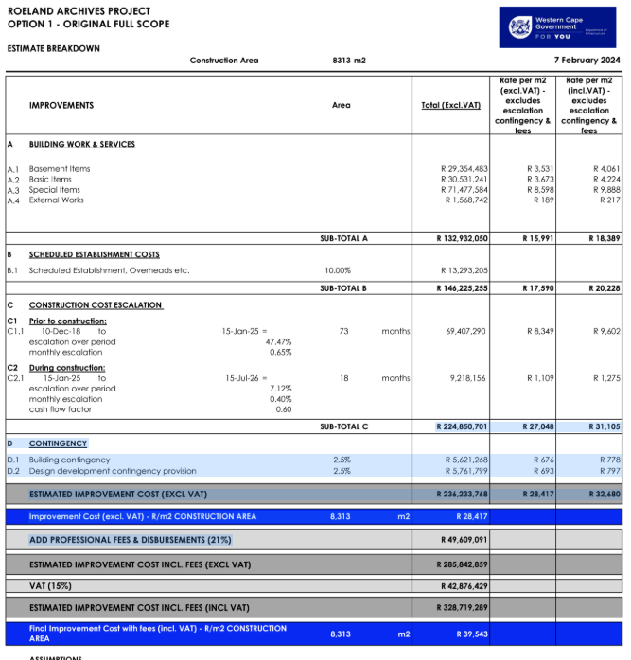

Figure 2: Cost Summary Table - Option 1

To date, all planning, design, and pre-construction work has been funded through public sector budgeting processes. Future funding for implementation is anticipated to come primarily from provincial capital allocations. The project’s submission for evaluation at the Panoptic Evaluation Scoring Sessions (July 2025) signals its intent to be included in the Western Cape’s strategic pipeline of infrastructure investment, as governed by the WCIF 2050, WCIS 2050, and WCIIP 2050 frameworks. These frameworks are designed to promote prioritised, risk-mitigated, and investment-ready projects that align with long-term public value.
While no specific revenue model is proposed, given that archives operate as a public good, the project creates indirect financial efficiencies. These include reduced reliance on expensive commercial storage, improved compliance that avoids audit findings and penalties, and faster administrative decision-making that supports cost-effective public service delivery.
Although no innovative financing mechanisms such as PPPs or blended finance arrangements are provided, the project’s readiness, strategic alignment, and long-term benefits make it a strong candidate for future exploration of alternative funding approaches. Its role in supporting better cooperation across government departments, the shift to digital systems, and the role it plays in protecting our shared history and culture, positions it well within the kind of investment portfolio envisaged by the Panoptic Principles and mission-oriented infrastructure.

- Project Feasibility, Approvals and Infrastructure Planning
The Provincial Archives Project has been developed through a detailed and structured feasibility and planning process, led by the DOI in collaboration with the DCAS. The findings of this process clearly confirm both the necessity and feasibility of the project. WCARS has reached full capacity, with a documented backlog of over 57,000 linear meters of unaccommodated records. Without intervention, this will continue to compromise legal compliance, increase operational risks, and impose unnecessary costs on departments and entities across the WCG.
The feasibility work is reflected in the Roeland Archives Project-Workstage 03 Report (dated February 2019) and the high-level cost estimate dated February 2024 (2024 02 07 - Roeland Street Archives Estimate R0[1].pdf), which together confirm that Phase 1 of the project is construction ready. Phase 1 includes the demolition of an inefficient wing of the existing building and the construction of a five-storey stack building with two basement levels, housing modern mobile shelving, scanning, cold storage, and digital infrastructure. A second, value engineered option was also considered to evaluate whether a reduced scope alternative could offer financial savings while still achieving strategic objectives. This option, at 6,975 m² and a reduced cost of R280 million, is more affordable but comes with limitations in capacity for future archival demand and therefore compromises long-term resilience.
The project is fully integrated into a six-phase Master Plan, which lays out a clear and staged infrastructure roadmap (see Figure 1: Phased Development Overview-Phases 1 to 6) . The Master Plan ensures long-term adaptability, enabling the facility to meet future demand growth, accommodate modern archival standards, and align with digital transformation objectives. Phases 2 to 6 will focus on refurbishing existing stacks, expanding staff and admin spaces, and delivering a new conference facility designed to support the Province’s long-term governance and public access goals.
From a planning and prioritisation perspective, the project has been formally submitted for inclusion in the Panoptic Evaluation Scoring Sessions, which are part of the provincial infrastructure pipeline development process under WCIF 2050 and WCIS 2050. This confirms that the project is being assessed using transversal, evidence-based criteria in line with the Western Cape’s infrastructure vision.
While detailed approvals such as environmental or regulatory compliance are not documented in the current set of reports, the project’s progression through formal planning stages suggests that these are being managed through standard departmental processes.

- Delivery Mechanism and Procurement Strategy
The Provincial Archives Project is structured around a phased delivery mechanism, guided by a six-phase masterplan that enables implementation to occur in manageable, costed segments aligned with budget availability and operational needs (see Figure 1: Phased Development Overview-Phases 1 to 6). This staged approach allows for risk mitigation, procurement flexibility, and infrastructure continuity.
Phase 1 is the most advanced and is construction ready, with all planning, costing, and design work completed. This phase will involve the demolition of the outdated South East Wing of the Roeland Street site and the construction of a new five-storey stack building with two basement levels, housing cold storage, scanning facilities, digital infrastructure, and high-density mobile shelving. The DOI, in partnership with the DCAS, has led the preparation of this phase, including the production of detailed cost estimates and escalation models as reflected in the 7 February 2024 financial estimate (2024 02 07 - Roeland Street Archives Estimate R0[1].pdf).
The project will be delivered using conventional public-sector procurement methods, in line with provincial and national supply chain regulations. While the documents do not detail specific bidding processes, the inclusion of professional fees, escalation rates, and contingency planning suggests that the project team anticipates open competitive tendering for construction contracts and professional service providers.
Supplier selection will likely be overseen by the DOI using established criteria including compliance with procurement legislation, technical capability, value-for-money principles, and alignment with project timelines. These processes are designed to ensure transparent, competitive procurement that supports economic participation and transformation objectives where possible.
While no formal risk-sharing mechanisms (e.g. PPPs or joint ventures) are mentioned in the current documentation, risk management has clearly been integrated into the project’s design and planning. The high level cost estimates account for pre and during construction escalation, as well as professional fees (21–22%) and a 5% combined contingency. These provisions reflect an understanding of procurement related risks such as price volatility, delays, and variations during implementation.
The project’s phased structure not only allows for funding alignment and manageable execution but also supports adaptive procurement across future phases (Phases 2 to 6), which will include refurbishment, administrative expansion, and public engagement facilities. This approach reinforces the project’s alignment with WCIF 2050, particularly the Panoptic emphasis on transversal governance, spatial justice, and long-term infrastructure resilience.

- Project Communication and Stakeholder Engagement.
The Provincial Archives Project is a public infrastructure investment with province wide significance, engaging multiple layers of government, regulatory authorities, and internal stakeholders across the Western Cape. While the documents reviewed do not provide a detailed communication strategy or stakeholder engagement plan, the project’s progression and inclusion in key planning processes clearly demonstrate active coordination with the relevant institutional actors.
The project is being led by the DCAS in close partnership with the DOI, reflecting a cross-departmental governance model that supports transversal alignment. This partnership underscores one of the core principles of the WCIF 2050 Panoptic Framework that integrated planning and delivery across government departments enhances both project effectiveness and stakeholder trust.
Government and regulatory interactions are evident in the project’s planned submission to the Panoptic Evaluation Scoring Sessions, which were scheduled for July 2025. This process serves as a key platform for infrastructure pipeline development in the province. Through this mechanism, the project is not only being reviewed for readiness and alignment with policy frameworks such as WCIS 2050 and WCIIP 2050, but is also being positioned for budget prioritisation and long-term investment inclusion. This marks an important avenue of primary stakeholder engagement within the context of public sector infrastructure. This process ensures key decision makers, including Treasury, Heads of Departments, and political authorities, are presented with a credible case for funding.
Although specific community participation activities are not referenced in the current documents, the project’s public value orientation, ensuring legal access to records, enabling transparency, and preserving shared heritage, indicates broad societal benefit. The infrastructure motivation document (File reference #: WCA12/1/1/1) further highlights how improved archival access supports community dignity, resolution of estates, and justice-related processes. These aspects reinforce the project’s relevance to social stakeholders, particularly vulnerable or historically marginalised communities who depend on reliable access to public records.
Going forward, the phased nature of the project provides opportunities for deeper public communication, including updates on construction progress, digital transformation efforts, and improved service offerings. As future phases include public-facing facilities such as a conference centre and reading rooms, stakeholder engagement will likely expand to include researchers, civil society organisations, and educational institutions.

- Special Procurement Actions and Social Impact
The Provincial Archives Project is designed as a public good infrastructure initiative with social benefits. While the project documentation does not include a specific social responsive procurement framework, it is being implemented under the auspices of the DOI and the DCAS, both of which operate within the WCG’s procurement policies that are guided by principles of equity, redress, and inclusion.
The project’s primary social value lies in its mandate to preserve, protect, and provide equitable access to public records. The current storage backlog of over 57,000 linear meters has a direct impact on the public’s ability to access information. This particularly affects those who rely on official documents to resolve estates, prove legal identity, or assert historical land or labour rights. These vulnerabilities often disproportionately affect women, elderly persons, rural populations, and those historically disadvantaged. By resolving the storage shortfall and enabling lawful, timely transfers of records to WCARS, the project helps reinforce administrative justice and dignity for all residents.
The project also contributes to the WCG’s broader sustainability goals. Phase 1 includes design elements that promote more sustainable archival practices, such as high-density mobile shelving, which maximises storage efficiency and reduces spatial demand. The inclusion of cold storage and digital infrastructure indicates a shift toward digitisation and energy-conscious records management. While no explicit reference is made to environmental compliance standards or certifications, the project’s intent to consolidate dispersed storage practices inherently reduces the carbon and operational footprint currently associated with fragmented off site storage.
On procurement, although detailed supply chain models are not specified in the documents, the project is expected to follow standard public procurement processes, including open and competitive tendering. This offers opportunities for inclusive supplier development, including participation by women-owned businesses, black-owned enterprises, and local contractors, in accordance with provincial supply chain regulations. The scale and phased nature of the project, create further potential for local economic participation and skills development over time.
In alignment with the WCIF 2050 Panoptic Principles, the project represents infrastructure that builds trust, promotes spatial justice, and supports long-term stakeholder value. Its role in protecting documentary heritage, supporting digital access, and promoting institutional integrity reflects a clear commitment to inclusive and sustainable development.

- Operations and Maintenance Strategy
The long-term success of the Provincial Archives Project depends not only on the delivery of new infrastructure but also on operations and maintenance strategy. While the documents provided do not include a dedicated O&M plan, the architectural and infrastructure design elements embedded in Phase 1 and the broader six-phase masterplan indicate a strong foundation for sustainable asset management, operational efficiency, and future-proofing.
The Roeland Street Archives Estimate and associated planning documents highlight key features that support long-term asset durability. These include the use of high density mobile shelving systems, specialised cold storage for fragile or sensitive materials, and integrated digital scanning and records infrastructure. Such features are not only space efficient but reduce wear on physical assets, extend the life of archival collections, and reduce dependency on high volume paper retrieval. The building design itself includes two basement levels and five above ground storeys, maximising footprint while allowing for spatial flexibility and controlled environmental conditions essential for archival preservation.
In terms of performance monitoring and management, the project’s readiness for integration into the Panoptic Evaluation Scoring Sessions implies a level of transversal accountability and structured oversight. Though no standalone KPIs are outlined, the project aligns with the WCIF 2050 Panoptic Principles, which promote transparency, sustainability, and adaptive governance, all of which require effective operational tracking and performance feedback loops.
The project also builds a platform for leveraging digital technology to modernise service delivery. The inclusion of scanning facilities and planning for digital records infrastructure positions WCARS to reduce manual handling of documents and move toward a hybrid or less paper records management environment. This enhances operational efficiency and supports broader goals of digital transformation within the WCG.
From a resilience and climate adaptation perspective, the consolidation of archival storage into a purpose-built, environmentally controlled facility inherently improves protection against environmental risks, including heat, moisture, and fire. The infrastructure also reduces the need for multiple, less-regulated off-site storage facilities, which often lack consistent environmental safeguards. While specific green building certifications or energy systems are not documented, the inclusion of cold storage, spatial efficiency, and digital workflows suggest an emerging commitment to climate-conscious operations.

- Conclusion and Call to Action
The Provincial Archives Project is a legally mandated, strategically aligned, and construction ready infrastructure initiative that delivers far-reaching benefits across governance, public service, and cultural heritage. With the Western Cape Archives and Records Service (WCARS) currently operating at full capacity and facing a backlog of over 57,000 linear meters of unprocessed records, the project responds directly to systemic risks affecting legal compliance, accountability, and citizen access to critical information.
Phase 1, valued at R328.7 million, is ready for implementation. It will deliver a purpose built archival facility featuring cold storage, high density shelving, and digital infrastructure. This will create much needed capacity while advancing digital transformation and operational resilience. Subsequent phases will refurbish, expand, and modernise the broader WCARS facility in alignment with the WCIS 2050 and the Panoptic Principles under WCIF 2050.

The project forms part of a credible, investment ready pipeline, and is submitted for consideration at the upcoming Panoptic Evaluation Scoring Sessions (July 2025). Inclusion in this process is a critical step toward securing the necessary funding and moving the project into execution.

We invite the relevant political authorities, infrastructure planning bodies, and heads of departments to support this strategic investment in institutional memory, good governance, and public trust.

Contact Information
For further information, technical documentation, or engagement regarding this prospectus, please contact:

Department of Cultural Affairs and Sport (DCAS)
Project Lead: xx
Email: xx
Phone: xx

Department of Infrastructure (DOI) – Built Environment Services
Technical Lead: xx
Email: xx
Phone: xx
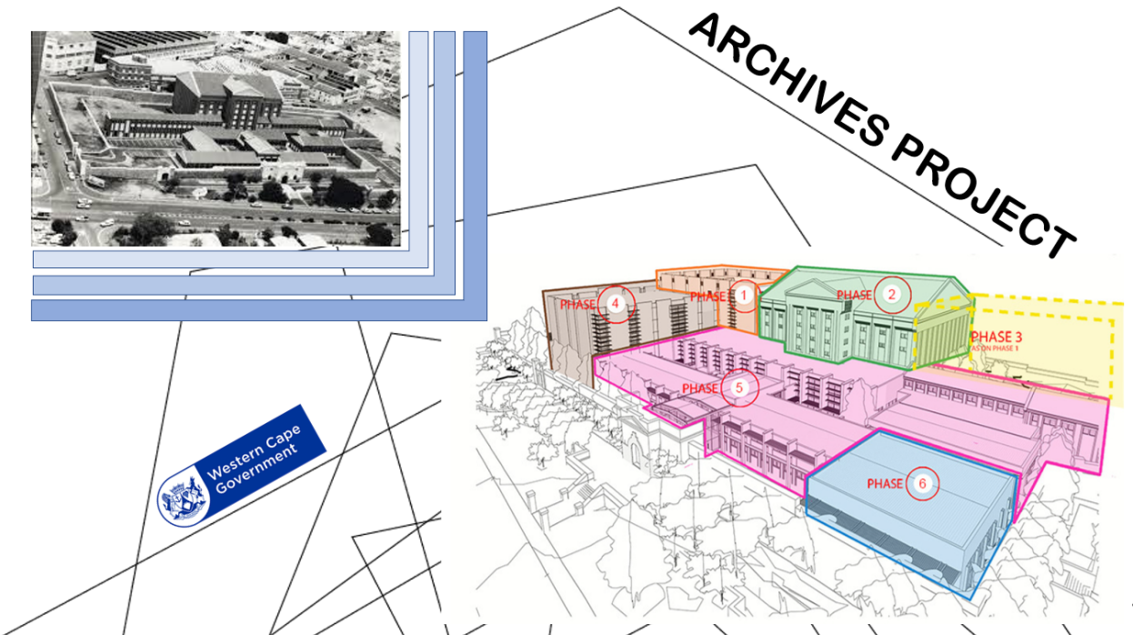

END
SE/C-Institite
Prospectus_Archives-Project_Aug2025

