Western Cape Infrastructure Project Pipeline

Document: Elevator Pitch
Project Name: Shayela Smart
Project Owner: Western Cape Government & City of Cape Town
Sector: Social & Technology Infrastructure
Date: November 2025

- Project Summary
Shayela Smart is a joint Western Cape Government, City of Cape Town, and SANTACO initiative designed to incrementally improve, integrate, and formalise minibus taxi (MBT) services across the province. It strengthens regulation, operational management, and system wide data visibility through remote holding areas, strategic stop-and-go facilities, driver registration, monitoring, and accredited training. Rooted in spatial justice and mission-oriented innovation, Shayela Smart builds a more efficient, safer, low-carbon and trusted public transport ecosystem serving communities historically excluded from reliable mobility.

- Project Status
Shayela Smart has a completed Business Plan and a clearly defined set of Phase 1 interventions, all aligned with the Province’s PLTF, the City’s CITP, IPTN, OLP and MYFIN frameworks. The programme has already secured high-level political endorsement and forms part of an established intergovernmental partnership with SANTACO Western Cape. National Treasury has requested that commercialisation options—such as on-site retail, services and data monetisation—be incorporated to strengthen the long-term funding case. The next step is securing implementation financing and finalising operational arrangements. The project is therefore positioned to advance into the bankable portfolio and be prepared for investor-facing packaging.

- PLTF — Provincial Land Transport Framework
- CITP — Comprehensive Integrated Transport Plan
- IPTN — Integrated Public Transport Network
- OLP — Operating Licence Plan
- MYFIN — Multi-Year Financial Operational Plan and Medium-Term Strategic Business Plan

- Financial Needs
Infrastructure requirements for initial implementation total approximately R94 million over the first two financial years, covering Remote Holding Areas (RHAs), Strategic Stop and Go (SS&G) facilities, fit-out, systems development and technology. Programme costs peak in the first three years before stabilising at around R135 million annually, including operations, training, monitoring, industry support and provincial staffing. Commercialisation, such as car washes, coffee kiosks, data services, and solar-equipped facilities, offers offset opportunities to strengthen long-term financial sustainability.

- Public/Private Sector Opportunity
Private sector investors can engage through:
- Commercialisation of RHA and SS&G sites including retail, services and on-site amenities.
- Technology partnerships for monitoring systems, data platforms, mobile devices and digital services.
- Renewable-energy solutions such as solar arrays and EV charging at remote holding facilities.
- Value-added offerings like onboard Wi-Fi or branding to diversify revenue and enhance customer experience.

- Investment Highlights
- Delivers strong socio-economic impact, improving access to opportunity in the province.
- Reduces congestion and emissions.
- Introduces scalable, technology-driven integration.
- Enables electronic ticketing and multi-modal integration.
- Creates diverse commercialisation opportunities.
- Offers strong value for money, delivering broad impact at far lower cost per passenger-kilometre.
- Provides clean-energy upside, with solar-ready facilities and potential EV charging infrastructure.
- Backed by strong governance, through a joint WCG–City–SANTACO partnership.
- Builds foundations for long-term reform, enabling larger vehicles, dedicated lanes, reciprocal routes and future formalisation under Phase 2.

- Key Parties
- Western Cape Government (Mobility Department)
- City of Cape Town (Urban Mobility Directorate)
- SANTACO Western Cape
- Umanyano Travel Services (UTS)
- MBT Associations and Operators
- National Treasury
- Provincial Regulatory Authority
- Facility Marshals
- Training Partners
- Industry Working Group (Shayela Smart)

- Map of the project:
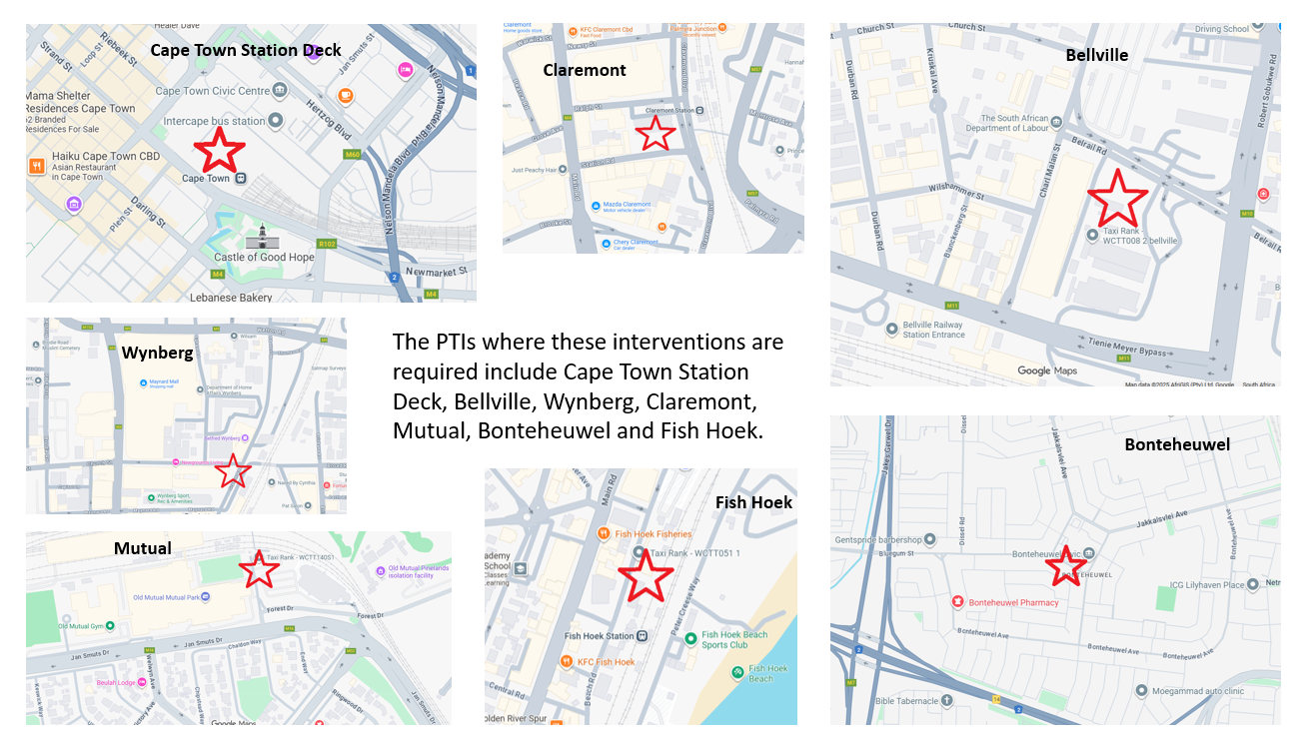

- Timeline
Phase 1a begins with Cape Town Station Deck, followed by Bellville, Claremont, Wynberg and other priority PTIs. Rollout continues route-by-route to minimise disruption, expanding across the metro over four years. Phase 1b extends to the broader province. Phase 2 (from year five) introduces larger vehicles, dedicated lanes, reciprocal routes, electronic ticketing and deeper formalisation.

END
SE/C-Institute
Elevator Pitch:_ Shayela Smart _Nov2025

