WCIIP 2050 DOI -Panoptic Evaluation Summary
Shayela Smart
Project Name:
DMSS01
Project Evaluation Reference:
15 OCTOBER 2025

Date of Evaluation:
Social & Technology Infrastructure
Sector:
Evaluation Team:
- Ms Deidré Ribbonaar
- Corrine Galant
- Mario Brown
- Shaldon J Le Roux
- Yumna Gihwala-Salie
- Lincoln Anthony
- Gavin Spannenberg
- Chad Capon
- Ziyaad Majiet
- Nadeem Hendricks

- SUMMARY OF PROJECTB
Background and Introduction:
Suite of minibus taxi (MBT) improvement and transformation interventions.
Shayela Smart is a joint initiative between Western Cape Government, City of Cape Town and SANTACO Western Cape to incrementally improve, integrate and formalise MBT services over the long-term, strengthen regulation and address key industry issues.
Infrastructure will need to be improved to support Shayela Smart
This entails the establishment of remote holding areas (RHA) and strategic stop and go (SS&G) facilities in the Metro to alleviate congestion at priority PTIs
The total infrastructure cost is approximately ~R94 million over the first two financial years:
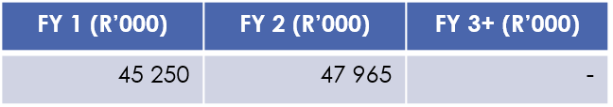
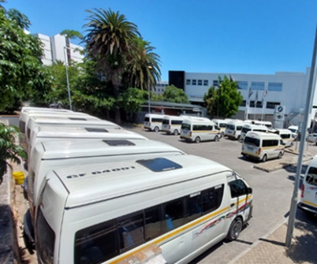
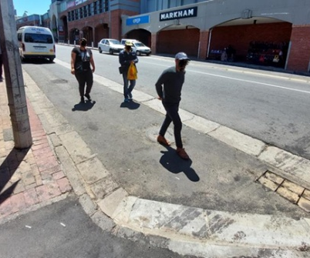

Total programme costs are as follows:
Establishment costs include: Systems development; vehicle fitout and branding; industry training
  - Capital costs include: Infrastructure and equipment (mobile devices, CCTV cameras, driver tags, vehicle trackers / tag readers)
  - Operational costs include: Systems maintenance and support; operational monitoring and support; industry management; driver awards to incentivise good performance; additional provincial staffing capacity to support management of the programme
Project costs will peak in the first three years of implementing the project, and are expected to stabilise at around R135 million per year thereafter.

Commercial opportunities & cost-effectiveness
Socio-economic and environmental benefits
Leverage the scale of the MBT sector to deliver meaningful economic upliftment through improved access to opportunities through more efficient operations and enhanced skills within the sector.
Enhance operational efficiency, increased passenger carrying capacity, and reduced congestion, leading to lower carbon emissions per capita, and supporting modal shift from private transport to public transport.

Integration and Technology
Technology-based interventions enhance ability to integrate MBT operations with formalised public transport services, thereby increasing the sustainability of public transport beyond MBTs, improving passenger experience.
Commercial partnership opportunities for features like onboard Wi-Fi or branded vehicles, which would generate additional revenue that could help to off-set operational costs and improve quality of services.
Value for money
Delivers wide-reaching benefits to the majority of public transport users at a significantly lower cost per passenger-kilometre than capital-intensive alternatives such as BRTs.
Reduces the need for more costly and operationally disruptive infrastructure upgrades at existing PTIs.

Clean energy
Potential for remote holding facilities to have solar panels fitted to offer long-term operation cost savings, and an opportunity to feed excess energy back into the grid, offering revenue offsets.
Potential for remote holding facilities to be equipped with EV charging equipment, to support interpeak EV charging, supporting the e-mobility transition, helping to reduce operational costs and lower carbon emissions.

Summary of Mobility related infrastructure needs
Establishment of remote holding areas (RHA) and strategic stop and go (SS&G) facilities in the Metro

Project Status:
- Business Plan completed
  - Request from NT to include commercialisation of sites e.g. Car Washes, Coffee Shops, Data commercialisation, etc.
  - Pitch it with the potential fiscal saving i.e. 5mill problem with a 50mill solution
- Efforts continue to secure funding for implementation

Business Plan Extract:
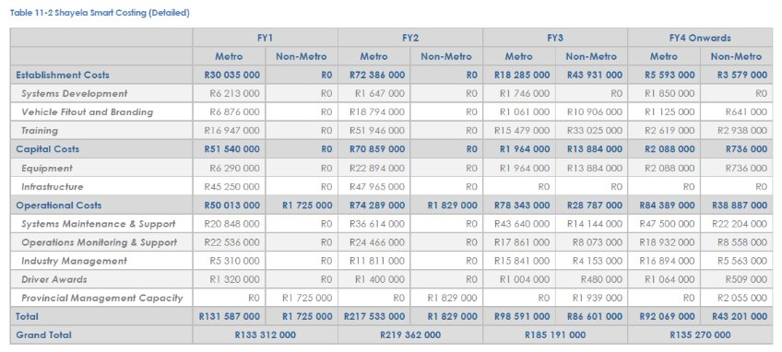
- OUTCOME OF EVALUATION
- Score: %

- ADDITIONAL NOTES:

Below some discussion notes that was mentioned during the Panoptic Scoring session mentioned under each sub-principle.
- Principle 1.1
  - Providing an infrastructure solution. Will enhance Operations via a remote holding area. An incremental and collaborative approach with key stakeholders.
  - Wynberg example (Holding Area) require an additional 3000 plus additional 2000 bays just to get it on par. (Minibus taxis) this technology will allow them to shuttle down to the holding area. Will be able to monitor how long the taxi stops etc. with the ability to then flag and notify the taxi drivers for infringing.
  - 2 sites have been identified within the Wynberg PTI - need to negotiate with National for this.
  - Need 15 seaters to accommodate the vast number of mini taxis required
  - Gerrit suggested to have a multi-purposed site, for commercial growth and repayment mechanism opportunities e.g. car wash, coffee shop, commercialise data, etc.

- Principle 1.2
  - Integration with law enforcement to ensure ease of governance
  - Reduced traffic congestion
  - Promotes zero emissions
  - Include strengthening the actual infrastructure with innovative ideas e.g. commercialisation mentioned earlier, in the business case to strengthen the motivation for funding

- Principle 2.1
  - Addressing maintenance, congestion, energy, emissions, etc.

- Principle 2.2
  - CoT, taxi council and province via the Mobility Department

- Principle 2.3
  - Local = 50 000+ people

- Principle 3.1
  - Ticks all the boxes strongly

- Principle 3.2
  - Improving everything

- Principle 3.3
  - Upskilling the minibus taxi industry
  - SETA accredited courses

- Principle 4.1
  - Clean Audit received
  - On myFin system – MFMA
  - Principle approved/endorsed by the Premier, the Mayor, Ministers, etc.

- Principle 4.2
  - Allows industry to maintain vehicles sufficiently Ito safety etc. Many people must walk up to or even further than 1km

- RECOMMENDATION
Project advances to the bankable portfolio and should be packaged into a standard draft elevator pitch and draft investor infrastructure prospectus that can be used to present to potential investors.

……………………………..…………. ………………………………………….
Chairperson Date

