Western Cape Infrastructure Project Pipeline

Document: Elevator Pitch
Project Name: Freight Rail Revitalisation Framework
Project Owner: Western Cape Mobility Department
Sector: Economic Infrastructure
Date: November 2025

- Project Summary
The Freight Rail Revitalisation Framework is the Western Cape’s coordinated effort to bring reliability, capacity, and economic value back to the province’s freight rail system. The project responds directly to declining rail performance, severe maintenance backlogs on branch lines, and the rising social, environmental, and financial costs of a road heavy freight economy. Drawing on detailed rail-flow analysis and the Western Cape Freight Demand Model, the framework identifies where rail-friendly commodities, particularly agriculture, manufacturing, and mining, can shift from road to rail, reducing congestion, emissions, and infrastructure degradation.
Anchored in national reform processes such as the National Rail Policy, third-party access, the Freight Logistics Roadmap, and the emerging role of the Transport Economic Regulator, the project positions the province as a convenor and enabler rather than an operator. It brings together Transnet Rail Infrastructure Manager (TRIM), municipalities, private operators, freight owners, and communities to revive feeder and short lines, develop a provincial terminal network, and unlock private-sector investment in infrastructure and operations.
The Framework aims to build a more resilient, reliable, and climate-aligned freight ecosystem: one where revitalised rail corridors support regional industries, stabilise export competitiveness, reduce road violence and transport-related disruptions, and strengthen long-term provincial growth.

- Project Status
The framework is at an advanced conceptual stage, with detailed rail-flow analyses completed, baseline and ideal modal-shift scenarios quantified, and priority feeder and short lines identified across the Western Cape. Provincial/National engagements are underway, with WCMD working closely with TRIM to verify branch-line condition, maintenance backlogs, cost implications, and emerging access arrangements under the Network Statement. Business case preparation is progressing for submission to the National Department of Transport (DoT) and Private Sector Participation Unit (PSP) Unit, supported by evidence from the Western Cape Freight Demand Model. The project aligns directly with national structural rail reforms—including third-party access, economic regulation, and the Freight Logistics Roadmap—and supports the development of early pilot projects and terminal concepts. It is recommended for progression into bankable project packaging to enable investor engagement and readiness.

- Financial Needs
The project’s financial needs span early-stage preparation through long-term capital investment. Initial funding is required for detailed feasibility studies on priority feeder and short lines, drawing on the Western Cape Freight Demand Model to quantify shiftable volumes, infrastructure condition, and operational viability. Additional resources are needed to analyse maintenance backlogs, clarify access tariffs under TRIM’s Network Statement, and define the cost structure for terminal development and necessary rolling stock.
Capital investment will be required to rehabilitate inactive or underperforming branch lines, upgrade sidings, improve signalling and security, and establish an integrated terminal network that supports rail-friendly commodities. These needs remain dependent on TRIM-confirmed cost baselines and the final access regime for the B-network.
Given Transnet’s constrained balance sheet and the national emphasis on structural reform, the project anticipates a combination of blended finance, provincial support mechanisms, climate-aligned funding, and private capital through PSP models such as concessions, service contracts, and asset-maintenance partnerships.

- Public/Private Sector Opportunity
- Invest in terminal development aligned with identified freight flows and provincial economic priorities.
- Partner on branch line revitalisation through concession models supporting long-term operational sustainability.
- Collaborate on feasibility studies, business cases, and pilot projects advancing freight modal shift.
- Co-fund infrastructure upgrades enabling rail access, reliability, and competitive logistics services.

- Key Parties
- Western Cape Mobility Department (WCMD)
- Western Cape Government (WCG)
- Transnet Rail Infrastructure Manager (TRIM)
- Department of Transport (DoT)
- Private freight operators and Train Operating Companies
- Municipalities across the Western Cape
- Rail Safety Regulator (RSR)
- Transport Economic Regulator (TER)
- PSP Unit (DoT/National Treasury)
- Freight owners: agriculture, manufacturing, mining sectors
- Western Cape Freight Demand Model (WCFDM) data partners

- Map of the Project
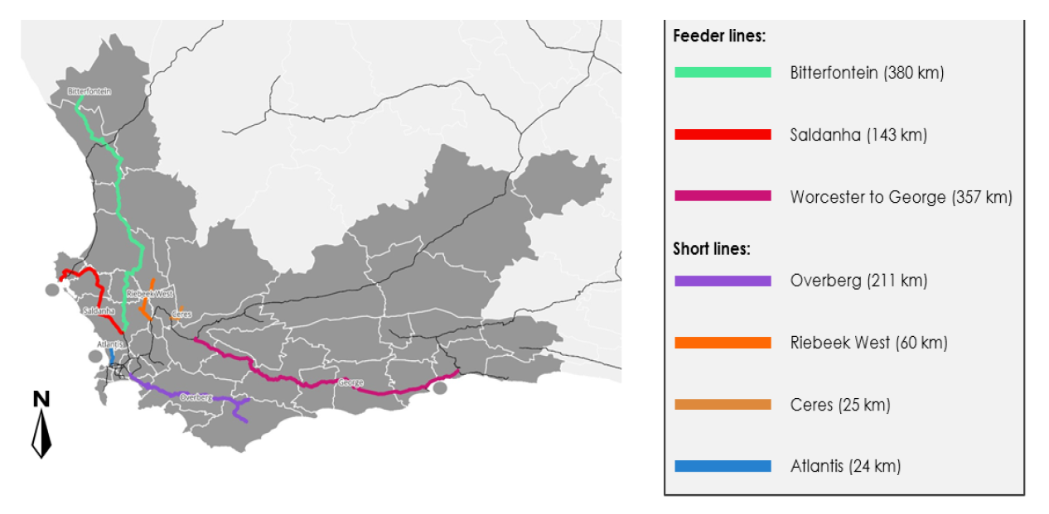
[Western Cape feeder and short lines map, including Bitterfontein, Saldanha, Worcester–George, Overberg, Riebeek West, Ceres, Atlantis]

- Timeline
- Short-term (Conceptualisation):
  - Complete rail analyses, stakeholder engagements, and preliminary business cases.
- Medium-term (Project Formation):
  - Advance feasibility studies, pilot terminal and branch-line projects, PSP preparations.
- Long-term (Implementation):
  - Deploy revitalised branch-line operations, expand terminal network, enable third-party access.
- Ongoing:
  - Reporting, monitoring, regulatory alignment, and refinement with national reforms.

END
SE/C-Institute
Elevator Pitch:_ Freight Rail _Nov2025

