WCIIP 2050 DOI -Panoptic Evaluation Summary
Freight Rail Revitalisation Framework
Project Name:
FRRF001
Project Evaluation Reference:
16 October 2025
Date of Evaluation:
Economic Infrastructure
Sector:
Evaluation Team:
- Ms Deidré Ribbonaar
- Corrine Galant
- Mario Brown
- Shaldon J Le Roux
- Gavin Spannenberg
- Yumna Gihwala – Salie
- Lincoln Anthony
- Chad Capon
- Ziyaad Madhot (not on platform)
- Gamza Martin (added)

- SUMMARY OF PROJECT
Background and introduction:
Initiatives to enhance regional rail connectivity, promote private sector investment, and support the revitalisation of branch lines and key regional freight corridors.

Overview

- Branch lines across the province (e.g., Overberg, Ceres, Saldanha) face severe maintenance backlogs.​
- Transnet Rail Infrastructure Manager (TRIM) is responsible for upgrades; cost and condition data remain unclear.​
- WCMD is engaging TRIM to clarify priorities, costs, and possible support models.​
- Mechanisms for investment in rail infrastructure and terminal network by other spheres of government and private sector must still be clarified.​

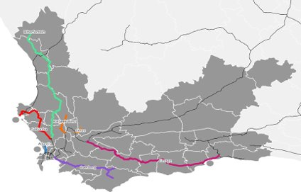

Infrastructure Opportunities

- A terminal network is needed to drive integration and support rail viability, i.e., rail supporting infrastructure
- Potential for WCMD, DOI (& municipalities) to provide land for facility/terminal development and collaborate with private sector to fund and develop the terminals
  - Costs and funding models for terminals require further development
  - Investment in rail network e.g., Bredasdorp/Protem and Swellendam)
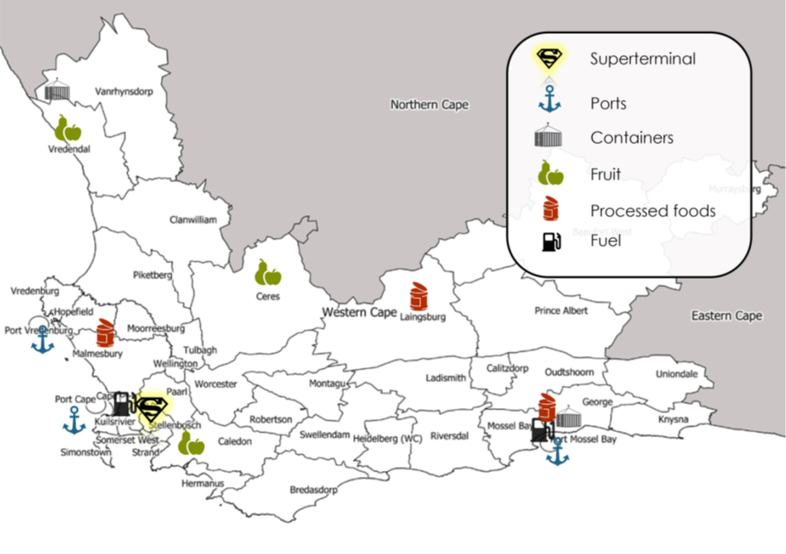
Potential Western Cape Terminal Network:

Potential Western Cape Terminal Network:
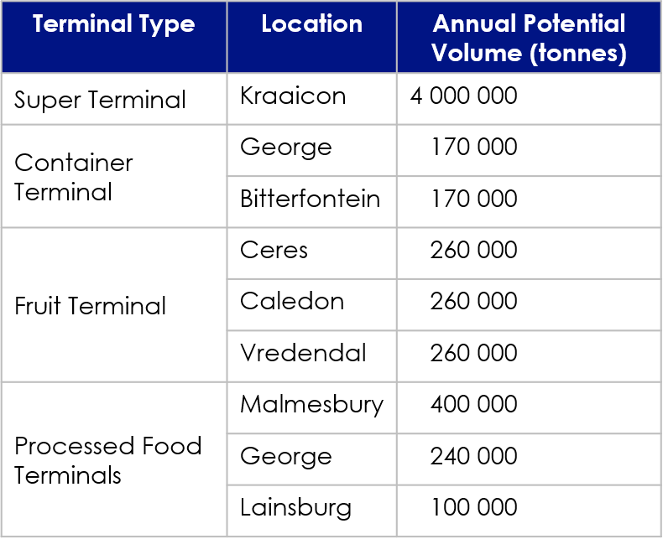

Summary of Mobility related infrastructure needs
Potential for WCMD, DOI & municipalities to support freight rail viability by providing land for facility/terminal development and collaborating with private sector to fund and develop the terminals

Potential Western Cape Terminal Network:
Key outcomes include:
- Freight plays a role in our daily lives from the farm, packing
- Underpins our economy, consider freight rail equally important
- It is reliant on some sort of commodity
- 99% of freight on our roles, (on our road)
- Doi infrastructure budget – we not moving enough freight on roads
- A national competency – DOE freight rail network it opens up opportunity for government
- Focus on our economic opportunities and social impact and divert our plan to revitalise. We must equally be innovative to public transport, need to replicate for the provincial government
- National – look a corridor revitalisation. We are complimenting a national.
- Going to get private, create a competition to efficiency, funding and investment will not be done. Creating an enabling environment for sector.
- This year implementing pilot project –
- Viable for agriculture – all being used by road. When accident on the road there is no work.
- International buyer goes to other suppliers if road transport is a problem (road violence)
- Right trade and investors
- Output will be a business case to investors take to the peace be unit at DOT
- Implementation plan to get contractual commitments to look at what it must look like
- 6 other opportunities in the Western Cape for infinite opportunities
- Impact will be considered going forward
- Commitment from producers
- For a terminal rail service to work you need commitment, understanding the viability of this project
- This is not a priority for National. Transport not going to look at the impact of the commodities
- Potential impact should this be viable there are lots of explanations.
- At national level it is big money, and they need to fix their main lines.
- National not focused on branch lines, and not going to invest. If provinces feel they need these lines, you must recruit in terms of transport services. Will move from strategic to non-strategic.
- On over Berger we can cover 300 costs
- We have the different scenarios and how we can make it viable
- More locatives are needed, and this will increase the cost
- Financially viable if you bring in more.
- Analysed the network
- Spade ready to do the feasibility – can take to networks and implement the design – but we are not there yet.
- Engaging ISA with memorandum of understanding
- Logistics value chain – increases other funding and
- Challenges sit with the overall, from private sector to freight guys, will have an impact on the GDP , supply chain from logistics.
- Freight of logistics put on hold for a year.

- OUTCOME OF EVALUATION
- Score: %

- ADDITIONAL NOTES:
Below some discussion notes that was mentioned during the Panoptic Scoring session mentioned under each sub-principle.

- Emphases made on how freight underpins our economy.
- Movement of freight adds to congestion problem, infrastructure damage and emissions.
- We are not moving enough freight on rail
- Transnet responsible for ensuring freight rail network
- Framework identifies support types.
- Projects compliments a national mandate
- Grains being moved along freight line.
- Shocking decline in rail services
- At Business case stage.
- Not a priority for national but important for provinces.

- RECOMMENDATION
Project advances to the bankable portfolio and should be packaged into a standard draft elevator pitch and draft investor infrastructure prospectus that can be used to present to potential investors.

……………………………..…………. ………………………………………….
Chairperson Date

