Western Cape Infrastructure Project Pipeline

Document: Elevator Pitch
Project Name: Cape Winelands Airport (CWA)
Project Owner: Cape Winelands Airport (Pty) Ltd
Sector: Transport Infrastructure / Aviation & Logistics
Date: November 2025

- Project Summary
Cape Winelands Airport (CWA) transforms the historic Fisantekraal Airfield into a sustainable, world-class aviation hub, Cape Town’s second international gateway. With environmental approval secured, the project advances from vision to reality, driving equitable economic, social, and environmental growth aligned with WCIF 2050. Guided by systems-based planning and transversal governance, CWA links aviation, logistics, and agri-industrial ecosystems to create regenerative infrastructure that powers inclusive mobility, opportunity, and climate-smart prosperity across the Western Cape.
By serving as a designated alternate airport for international carriers, CWA enables airlines to optimise flight planning by reducing reserve fuel loads and thereby cutting emissions, lowering costs, and increasing payload capacity for cargo and passengers. This unique operational advantage strengthens CWA’s environmental credentials and also enhances the economic viability of air routes to the Western Cape.

- Project Status
Cape Winelands Airport has received Environmental Authorisation (EA) from the Western Cape Department of Environmental Affairs and Development Planning (DEA&DP), marking a decisive milestone in its expansion journey. The approval follows over 40 specialist studies and four rounds of public participation, confirming full regulatory compliance and environmental integrity. With EA secured, CWA advances toward financial close and construction procurement for Phase 1’s runway and core infrastructure, targeted for 2026.

- Financial Needs
CWA represents an R8 billion catalytic investment mobilised through a blended finance model, combining private equity, debt financing, and strategic PPP participation. The project offers an estimated target equity return of 17 to 19%, supported by diversified revenue streams from passenger, cargo, logistics, and commercial estate operations. Funding will deliver Phase 1’s runway, terminals, utilities, and renewable energy systems, positioning CWA as one of the greenest airports in Africa. Phase 1 focuses on core aviation infrastructure, while Phase 2 expands into a multimodal logistics and agribusiness precinct, amplifying long-term investor value. Financial close is targeted for 2026, enabling construction toward full operational readiness by 2028.

- Public/Private Sector Opportunity
Private sector investors can engage through:
- Equity participation in Phase 1’s runway, terminal, and aviation systems development, with expansion to commercial real estate and logistics precincts in Phase 2.
- Strategic partnerships in aviation operations, cargo, renewable energy, agribusiness, and hospitality.
- Investment in CWA’s green infrastructure model, leveraging circular economy design and sustainability-linked incentives.
- Participation in the airport’s alternate fuel and operational efficiency platform, enabling measurable carbon and cost savings for airlines.

- Investment Highlights
- Addresses critical airport capacity shortages, providing alternate airport capability for inbound flights to Cape Town.
- Developed and managed by a leadership team with over 100 years’ combined airport development experience.
- Designed to be among the greenest airports globally, integrating renewable energy, circular economy systems, and low-carbon operations.
- Phase 1 (2026–2029): Core runway and terminal infrastructure; Phase 2 (2030–2035): Airport city, inland port, and Agri-zone.
- Targets 17–19% equity internal rate of return with diversified revenue across aviation, logistics, and property.

- Key Parties
- Cape Winelands Airport (Pty) Ltd - Project Owner and Developer
- WCG Department of Environmental Affairs and Development Planning (DEA&DP) - Environmental Authority (EA granted October 2025)
- Department of Infrastructure (DOI) - coordinating, enabling, and oversight
- South African Civil Aviation Authority (SACAA) - Regulatory Oversight
- Airports Company South Africa (ACSA) - Industry Stakeholder
- Air Traffic and Navigation Services (ATNS) - Airspace Coordination
- Municipality of Cape Town - Infrastructure and Spatial Planning Partner
- Fisantekraal and Kraaifontein - Communities surrounding the CWA
- General Aviation (GA) stakeholders/interests - non-commercial aviation such as private flying, flight training, recreational aviation (e.g. gliding, paragliding), and small charter operations.
- Munich Airport International GmbH (MAI) - Technical Partner
- Investec Bank / WB Capital - Financial Advisors

- Map of the Project

The map illustrates the approximate location of Cape Winelands Airport (CWA), strategically positioned between the three major regional growth centres of Cape Town, Stellenbosch, and Drakenstein, as well as its proximity to Cape Town International Airport (CTIA).
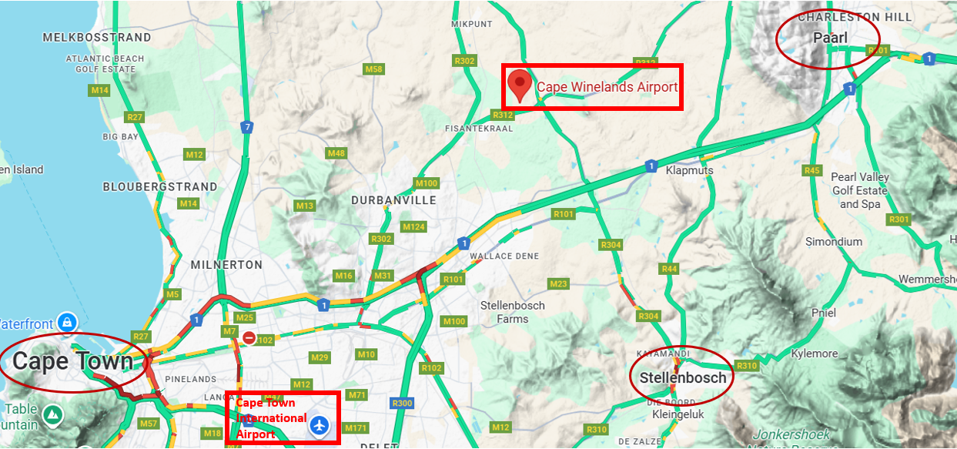
[Location of the Cape Winelands Airport (CWA) relative to regional centres & Cape Town International Airport]

- Timeline (Major Milestones)

Phase |  | Period | Key Milestones
1 | Project Inception & Acquisition | 2020-2021 | Acquisition of the former Fisantekraal Airfield by Cape Winelands Airport (Pty) Ltd.
1 | Project Inception & Acquisition | 2020-2021 | Establishment of corporate governance structures and technical partnerships.
1 | Project Inception & Acquisition | 2020-2021 | Initial master planning aligned to the Western Cape Infrastructure Framework (WCIF 2050).
2 | Feasibility, Planning & Environmental Approvals | 2021-2025 | Detailed feasibility and technical studies (airspace, socio-economic, environmental, diversion airport, alternate aerodrome).
2 | Feasibility, Planning & Environmental Approvals | 2021-2025 | Stakeholder and public participation under NEMA and DEA&DP oversight.
2 | Feasibility, Planning & Environmental Approvals | 2021-2025 | Environmental Authorisation Granted – 27 October 2025
2 | Feasibility, Planning & Environmental Approvals | 2021-2025 | SACAA compliance confirmation; endorsement of independent operations.
3 | Financial Structuring & Pre-Construction | 2025-2026 | Financial close targeted for mid-2026 (USD 550 million).
3 | Financial Structuring & Pre-Construction | 2025-2026 | Finalisation of PPP, debt, and equity structures.
3 | Financial Structuring & Pre-Construction | 2025-2026 | Appointment of EPC contractors and enabling works tendered.
3 | Financial Structuring & Pre-Construction | 2025-2026 | Detailed design and permitting for utilities (power, water, waste, and access roads).
4 | Construction Phase 1 - Core Airport Infrastructure | 2026-2029 | Construction of 3.5 km Code 4F runway (orientation 01–19).
4 | Construction Phase 1 - Core Airport Infrastructure | 2026-2029 | Development of terminal, airside and landside precincts.
4 | Construction Phase 1 - Core Airport Infrastructure | 2026-2029 | Installation of navigational aids, ATC systems, and renewable energy infrastructure (solar PV).
4 | Construction Phase 1 - Core Airport Infrastructure | 2026-2029 | Commissioning of utilities, road access, and biodiversity offsets.
5 | Commissioning & Operations Launch | 2029-2030 | Operational readiness and safety certification (SACAA).
5 | Commissioning & Operations Launch | 2029-2030 | Inaugural commercial and cargo flights.
5 | Commissioning & Operations Launch | 2029-2030 | Establishment of the Airport Task Force for continuous systems optimisation.
5 | Commissioning & Operations Launch | 2029-2030 | Activation of local skills development and SME integration programs.
6 | Phase 2-Airport City Expansion & Agri-Zone Development | 2030-2035 | Expansion into multimodal inland port, logistics, and agribusiness zones.
6 | Phase 2-Airport City Expansion & Agri-Zone Development | 2030-2035 | Integration of research, tourism, and green technology clusters.
6 | Phase 2-Airport City Expansion & Agri-Zone Development | 2030-2035 | Full circular economy implementation (biodigester, waste-to-energy, regenerative landscaping).
7 | Long-Term Growth & Regeneration Cycle | 2035 onward | Continuous adaptive management aligned to WCIF 2050 and climate targets.
7 | Long-Term Growth & Regeneration Cycle | 2035 onward | Smart systems integration (AI-based ATC, energy optimisation).
7 | Long-Term Growth & Regeneration Cycle | 2035 onward | Evaluation of social, environmental, and financial capital performance.

END
SE/C-Institute
Elevator Pitch: Cape Winelands Airport _Oct2025

