This is the sanity testing checklist for Panoptic Evaluation –
- Login to Platform
- Go to Panoptic Evaluation Dashboard, following screen will appear –
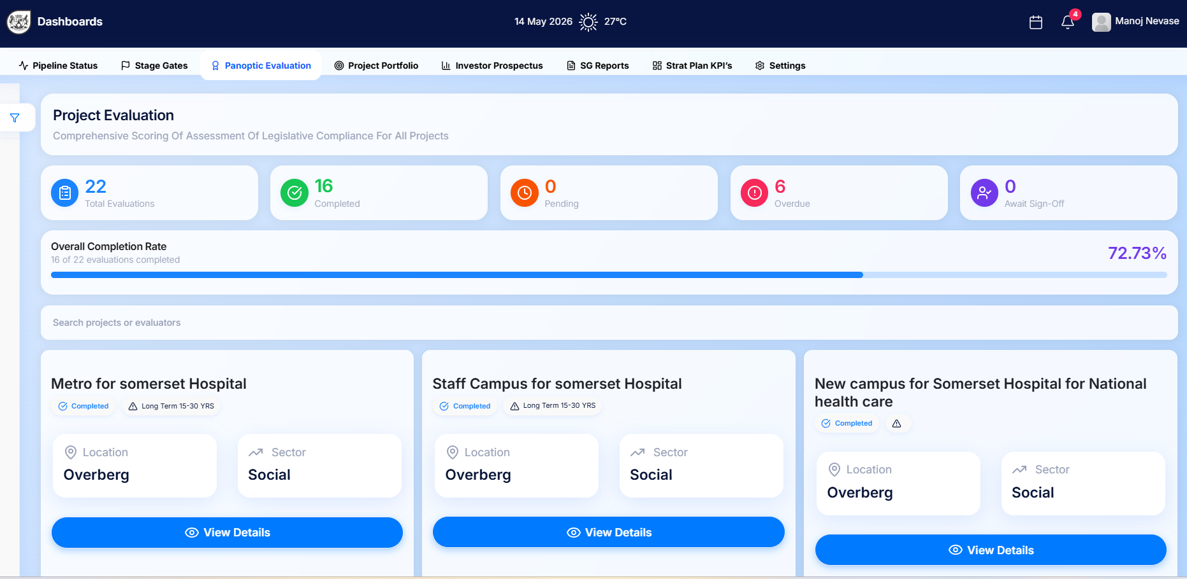
- Check if navigation from Main dashboard to “Panoptic Evaluation” and vice versa is working. Pass
- Check the counts and percentage are correct.Pass
- Check if counts on dashboard are clickable and after click the project list is displayed
- The navigation to project list and back is working smooth.Pass
- Check if project name, status of evaluation, duration/timeline, location and sector are appearing properly.Pass
- Check if project “View Details” button is enabled.Pass
- Check if “View Details” on click navigated to project evaluation below screen.Pass

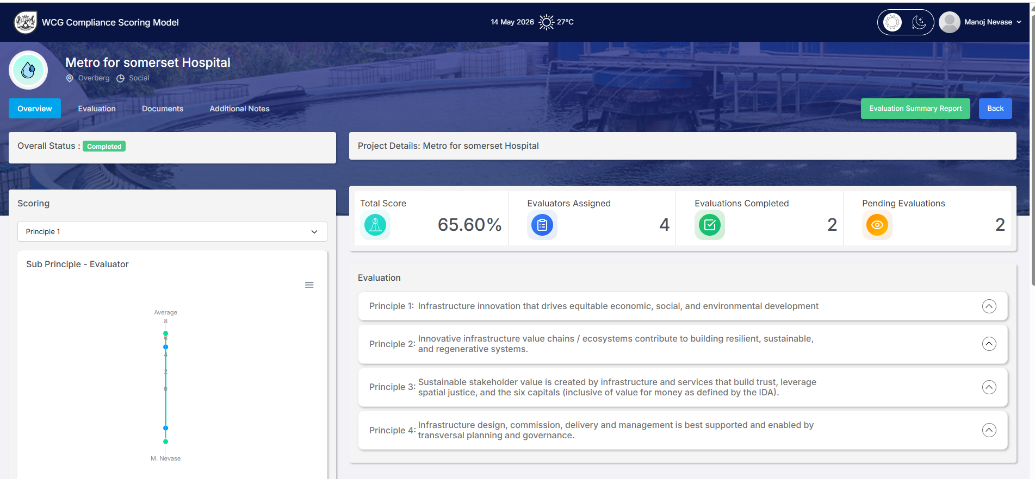

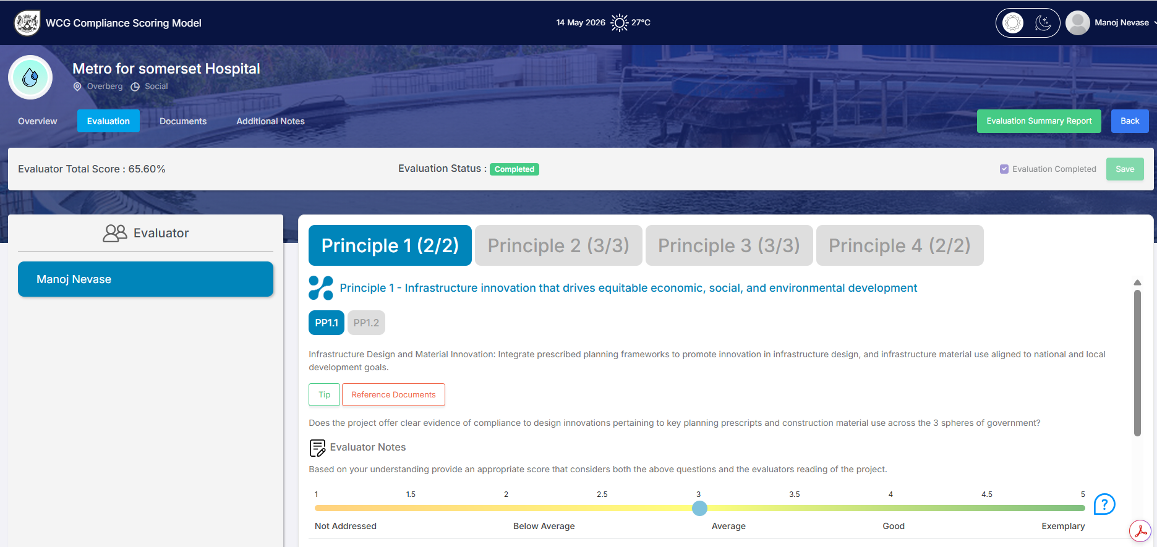
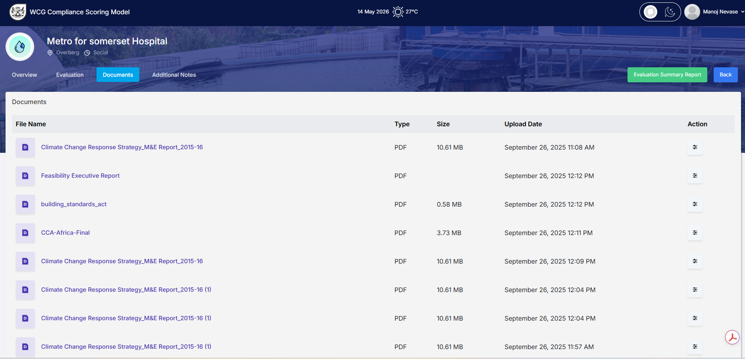
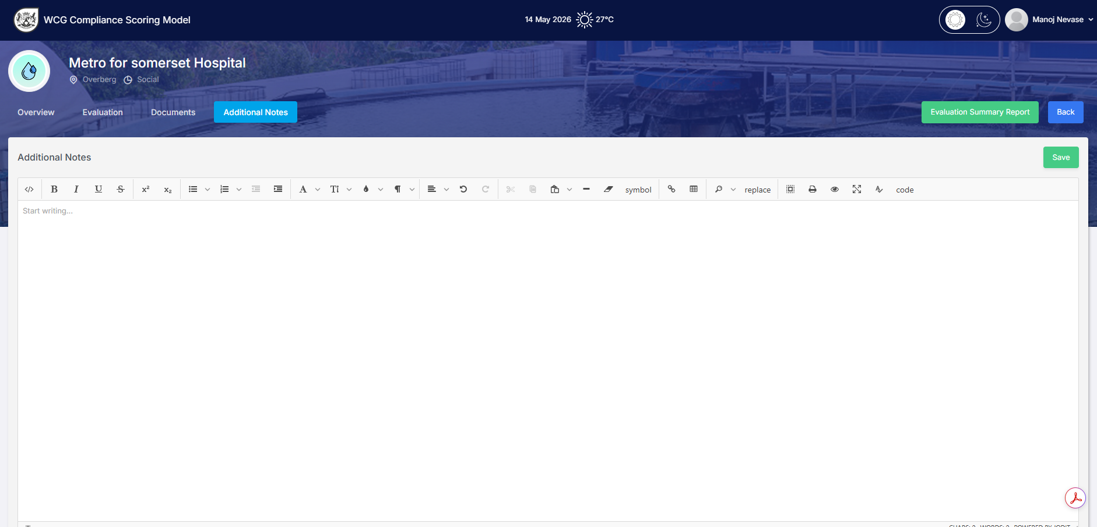

- Navigate through the project specific evaluation dashboard like Overview, Evaluation, Document, Additional Notes working fine.Pass
- Check Document link working fine.Pass
- Check all graphs, percentage, counts and text displayed correctly.Pass
- Check if Evaluation Summary Report and Back button working fine.Pass
- Check if it gives appropriate prompts while scoring, saving, completing and adding and editing notes.Pass
- Check if all required evaluators are listed for admin user and scores are displayed for evaluator login.Pass
- Project name, location and sector is displayed correctly.Pass
Following are the screens with Admin login –
- Dashboard screen –
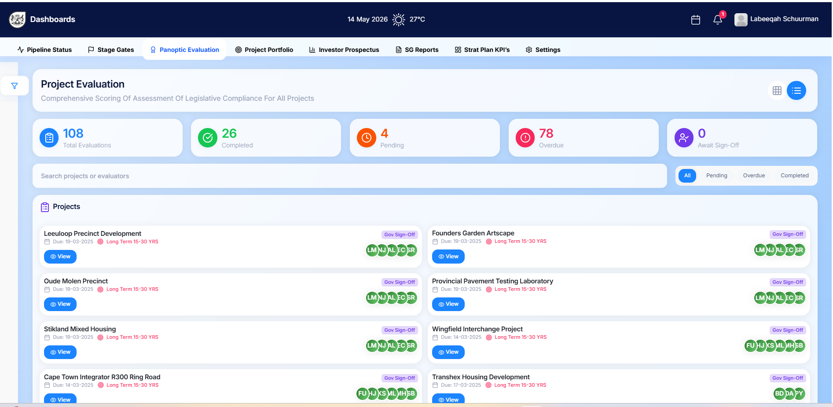
- Check if on hover the details are displayed.Pass
- Check if filter is working fine and search is also working fine.Pass
- Check if Evaluation Due date and Timeline is appearing fine .Due date is not visible
- Check if no and List of evaluators are correct and details are visible .Pass
- Check if Project view and Evaluator view are working fine.Pass
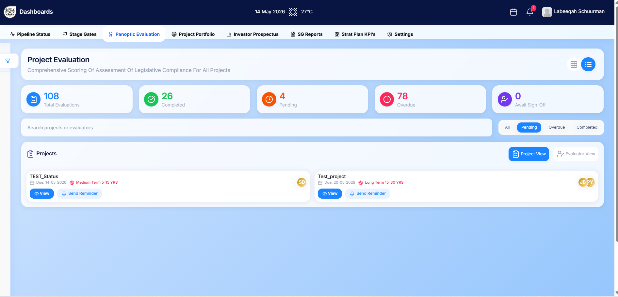
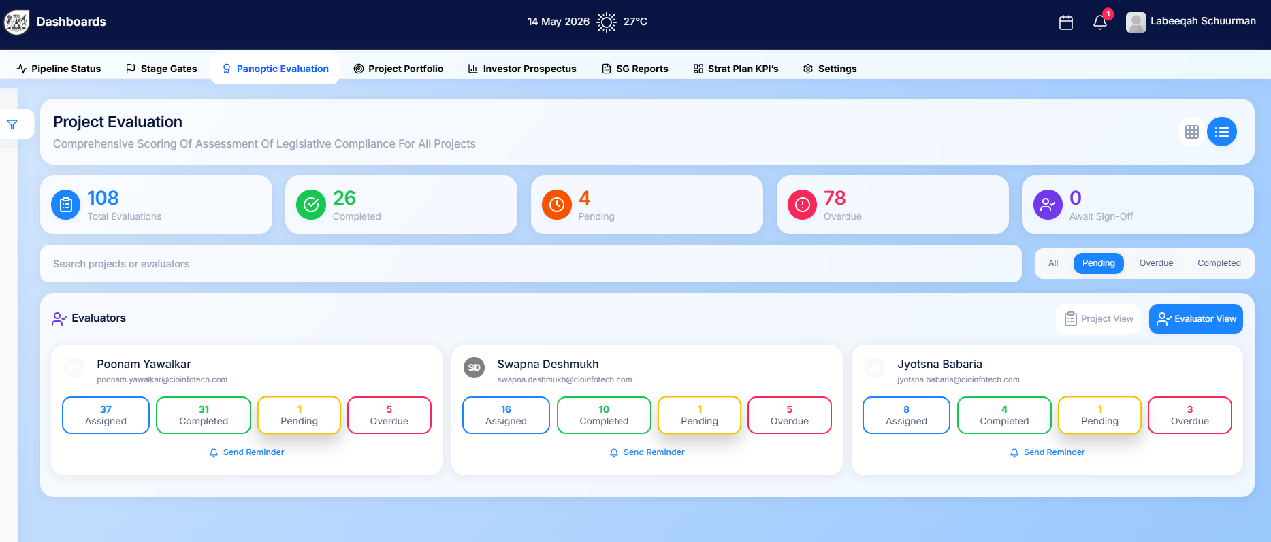

- Check if reminder pop up and send reminder working fine
- Check if all the status dashboards and its details in below panel are working fine.Pass

- Check if view button is working and Panoptic Evaluation screens display as appropriate – Pass
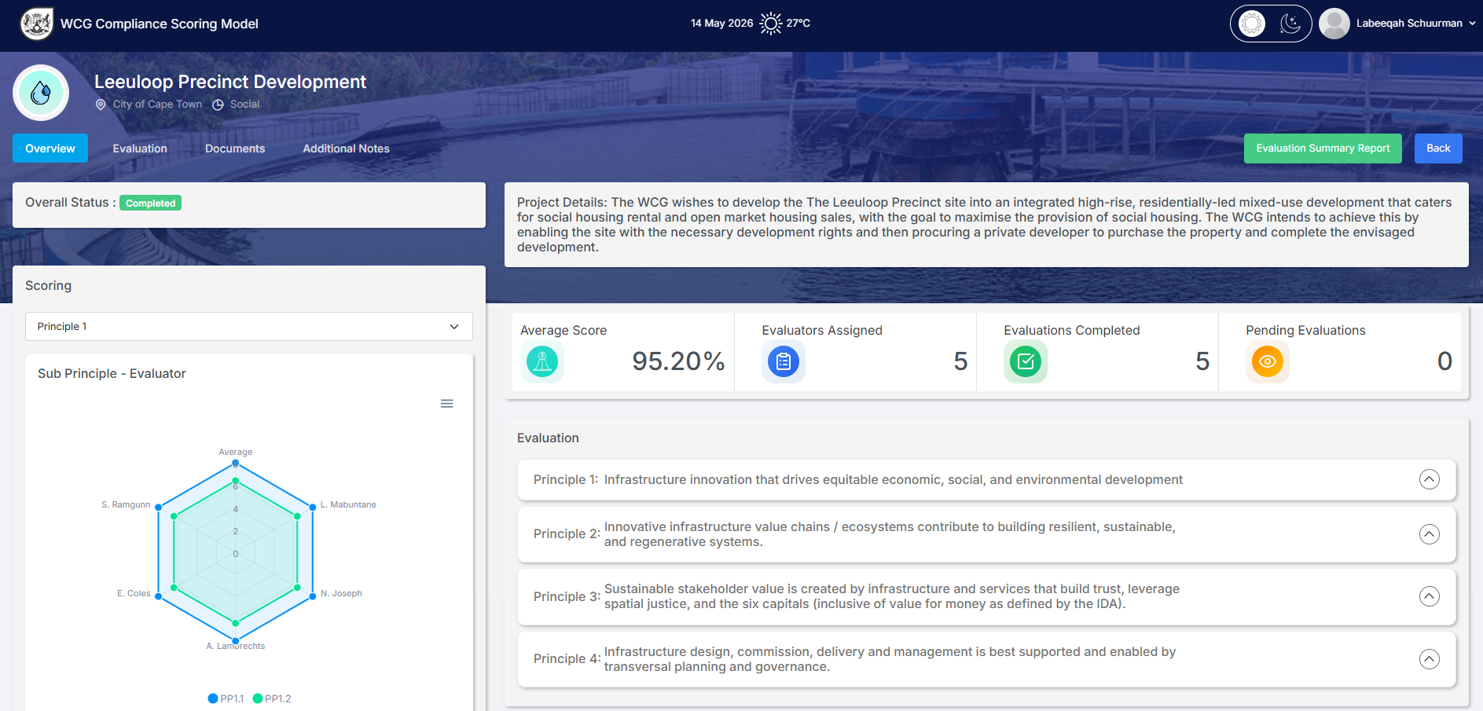
- Do similar checking like navigation and details in all 4 screens of the project evaluation .Pass
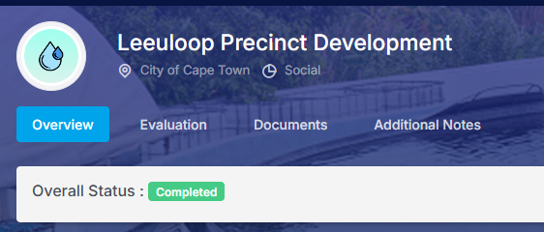

- Check if Evaluation Summary Report is working for Admin and it display below screens .Pass
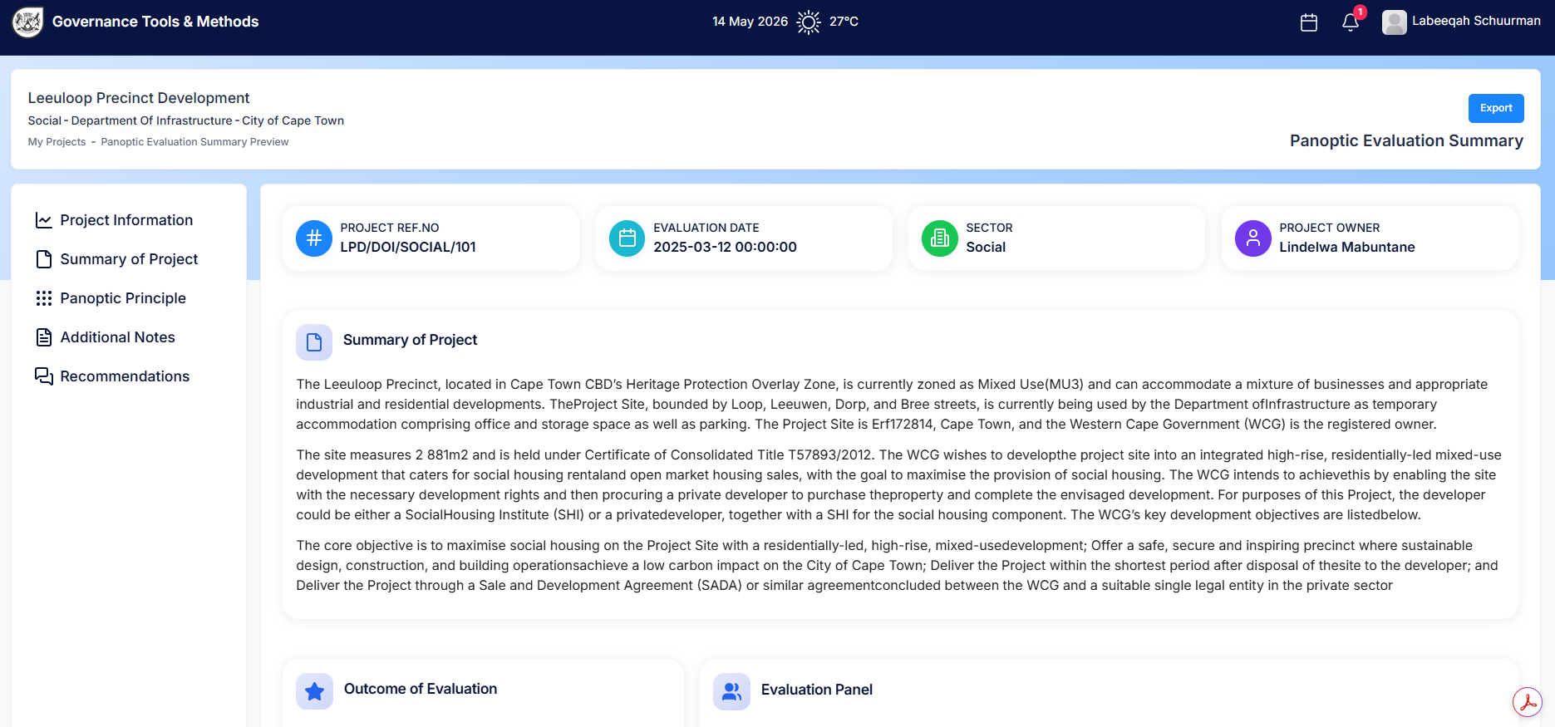
- Check if report left side panel navigation is working fine , details are appropriate, graphs are displayed and export option working.Pass

