Stage 0 and Stage 1
1)
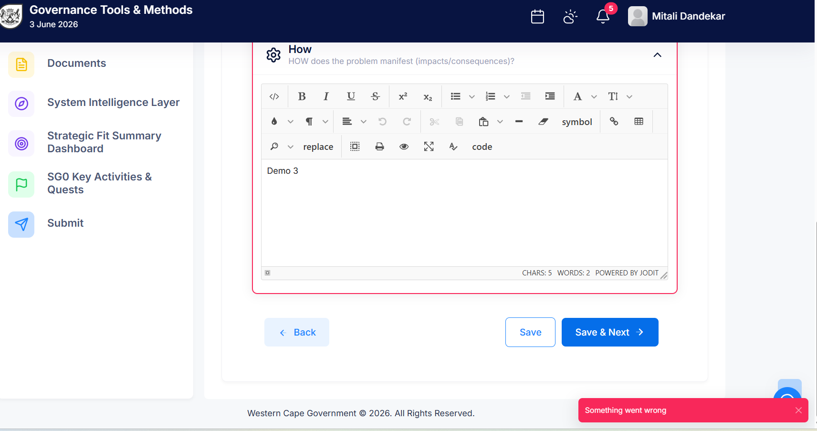
After entering all data its showing error “Something went wrong”.
2) 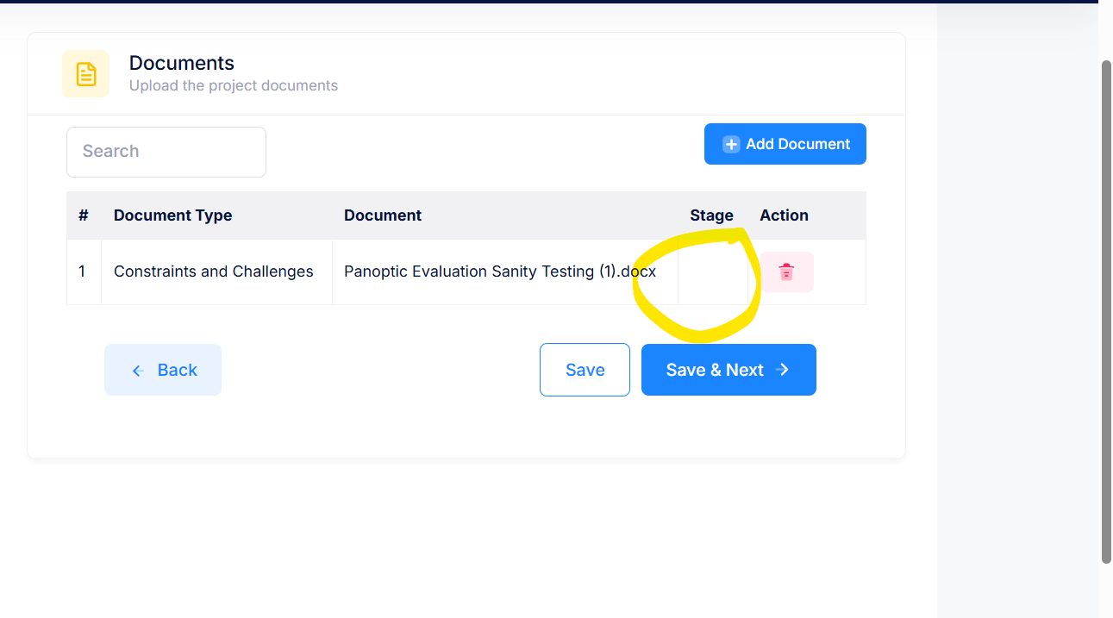
Stage missing

Stage 1
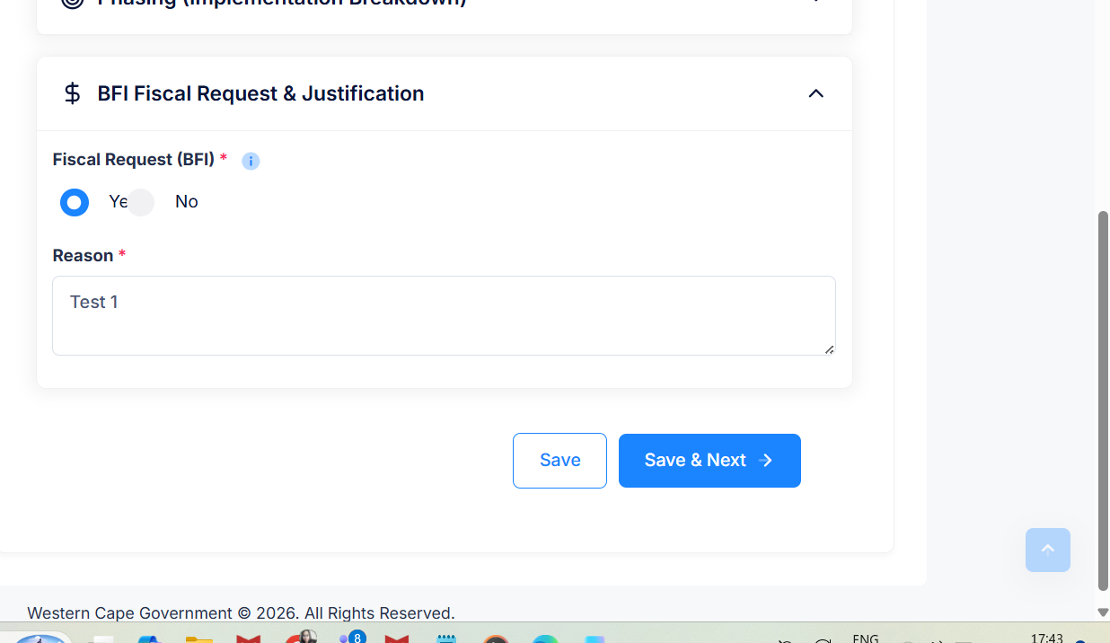
UI

There should be option of entering year
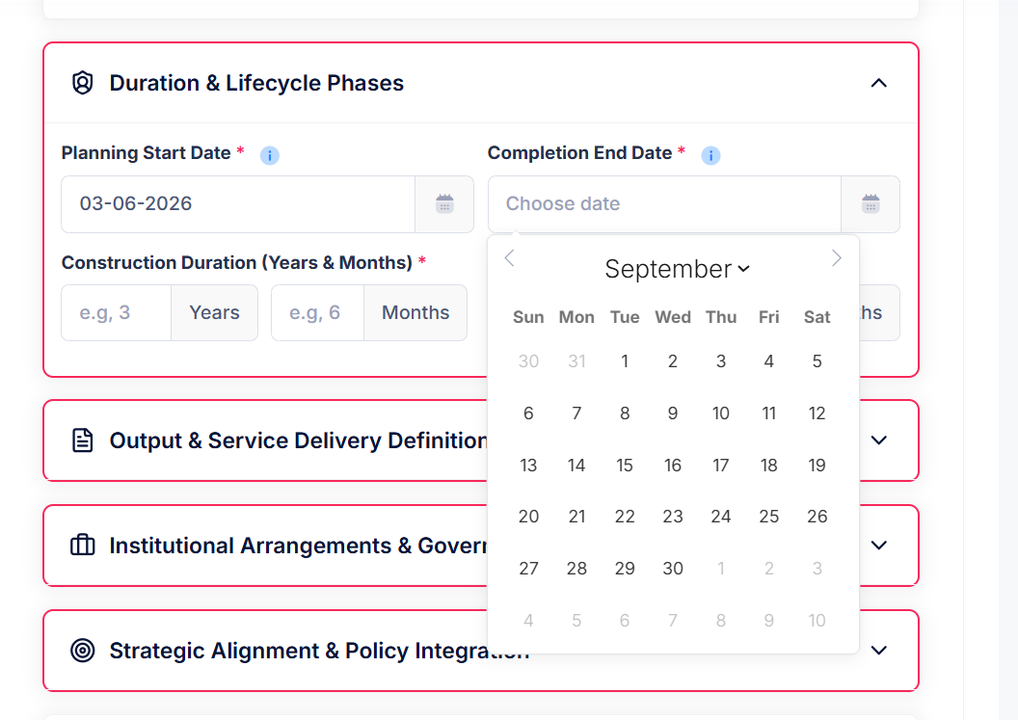
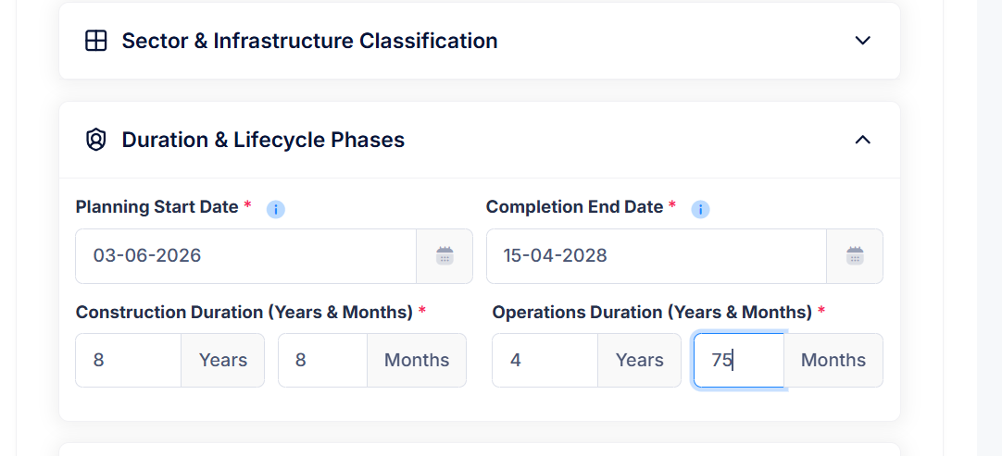
Months
Validation
3)In some Text Editors even after entering Text mandatory red alert is appearing for some time.

